PL/SQL

1.CONTROL STRUCTURES

CREATE TABLE customers ( customer_id INT, name VARCHAR(50), age INT, balance DECIMAL(10,2), interest_rate DECIMAL(5,2), isvip VARCHAR(5) );

-- Insert some sample rows INSERT INTO customers VALUES (1, 'Alice', 65, 12000.00, 7.5, 'FALSE'); INSERT INTO customers VALUES (2, 'Bob', 45, 8000.00, 8.0, 'FALSE'); INSERT INTO customers VALUES (3, 'Charlie', 70, 15000.00, 6.5, 'FALSE'); INSERT INTO customers VALUES (4, 'David', 30, 5000.00, 9.0, 'FALSE');

-- Scenario 1: Apply 1% discount to customers above 60 years old UPDATE customers SET interest_rate = interest_rate - (interest_rate * 0.01) WHERE age > 60;

-- Scenario 2: Promote to VIP based on balance UPDATE customers SET isvip = 'TRUE' WHERE balance > 10000;

-- View updated table SELECT * FROM customers;

OUTPUT SCREENSHOT:

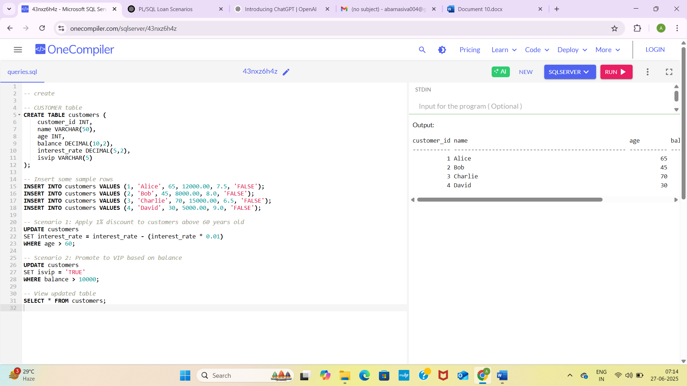

2.ERROR HANDLING:

CREATE TABLE accounts (

account_id INT PRIMARY KEY,

balance DECIMAL(10,2)

);

CREATE TABLE employees (

employee_id INT PRIMARY KEY,

name VARCHAR(50),

salary DECIMAL(10,2)

);

CREATE TABLE customers (

customer_id INT PRIMARY KEY,

name VARCHAR(50),

balance DECIMAL(10,2)

);

CREATE TABLE error_log (

message VARCHAR(255),

error_time DATETIME

);

-- Step 2: Insert sample data

INSERT INTO accounts VALUES (1, 5000.00), (2, 3000.00);

INSERT INTO employees VALUES (101, 'Alice', 60000.00), (102, 'Bob', 50000.00);

INSERT INTO customers VALUES (201, 'Charlie', 7000.00);

-- Step 3: Transfer funds with error handling

BEGIN TRY

BEGIN TRANSACTION;

DECLARE @balance DECIMAL(10,2);

DECLARE @amount DECIMAL(10,2) = 10000;

DECLARE @from_acct INT = 2;

DECLARE @to_acct INT = 1;

SELECT @balance = balance FROM accounts WHERE account_id = @from_acct;

IF @balance < @amount

THROW 50001, 'Insufficient funds', 1;

UPDATE accounts SET balance = balance - @amount WHERE account_id = @from_acct;

UPDATE accounts SET balance = balance + @amount WHERE account_id = @to_acct;

COMMIT;

END TRY

BEGIN CATCH

ROLLBACK;

INSERT INTO error_log(message, error_time)

VALUES(ERROR_MESSAGE(), GETDATE());

END CATCH;

-- Step 4: Update salary with error handling

BEGIN TRY

BEGIN TRANSACTION;

DECLARE @emp_id INT = 999;

DECLARE @percent DECIMAL(5,2) = 10;

UPDATE employees

SET salary = salary + (salary * @percent / 100)

WHERE employee_id = @emp_id;

IF @@ROWCOUNT = 0

THROW 50002, 'Employee not found', 1;

COMMIT;

END TRY

BEGIN CATCH

ROLLBACK;

INSERT INTO error_log(message, error_time)

VALUES(ERROR_MESSAGE(), GETDATE());

END CATCH;

-- Step 5: Add customer with duplicate ID to test error handling

BEGIN TRY

INSERT INTO customers(customer_id, name, balance)

VALUES(201, 'DuplicateCharlie', 9999.00);

END TRY

BEGIN CATCH

INSERT INTO error_log(message, error_time)

VALUES(ERROR_MESSAGE(), GETDATE());

END CATCH;

-- Step 6: View results

SELECT * FROM accounts;

SELECT * FROM employees;

SELECT * FROM customers;

SELECT * FROM error_log;

OUTPUT SCREENSHOT

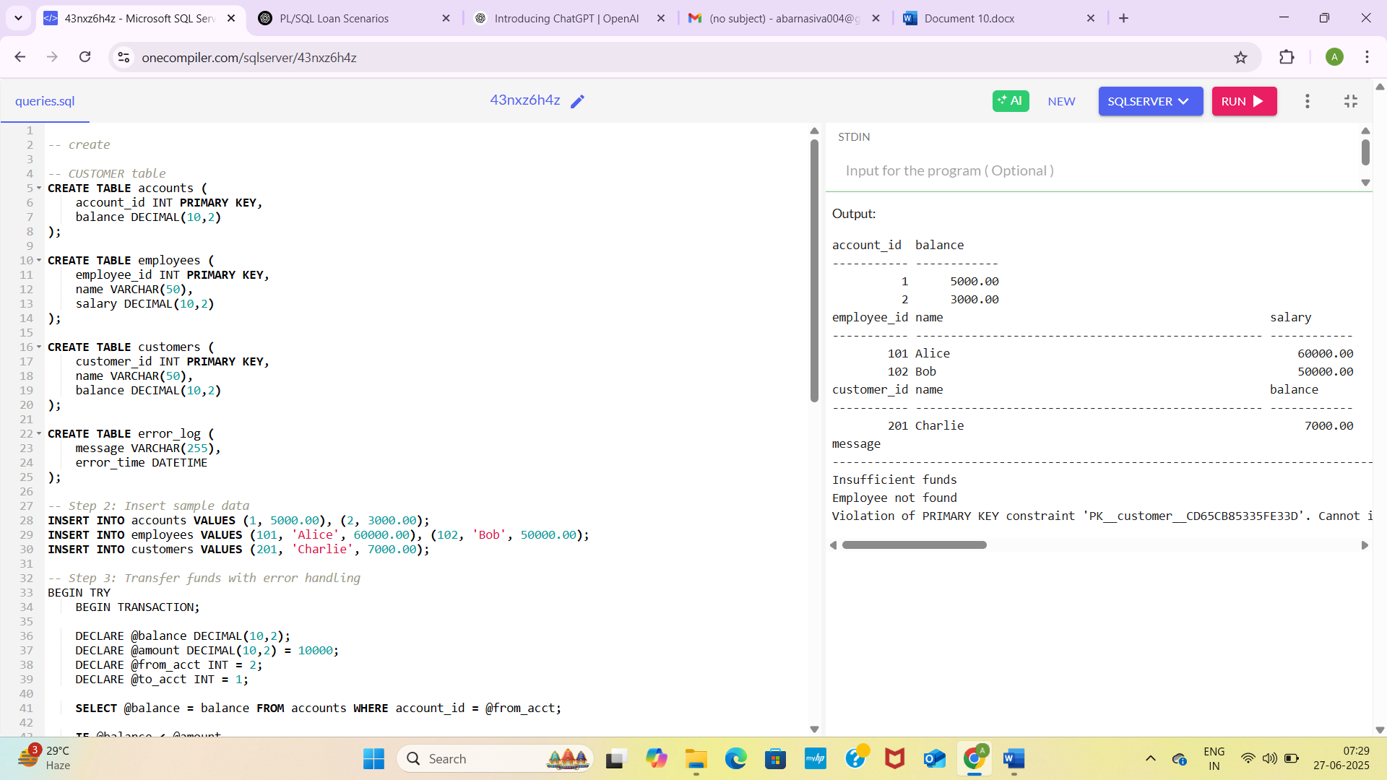

3.STORED PROCEDURES:

CREATE TABLE savings_accounts ( account_id INT PRIMARY KEY, customer_name VARCHAR(50), balance DECIMAL(10,2) );

CREATE TABLE employees ( employee_id INT PRIMARY KEY, name VARCHAR(50), department VARCHAR(50), salary DECIMAL(10,2) );

CREATE TABLE accounts ( account_id INT PRIMARY KEY, balance DECIMAL(10,2) );

-- Step 2: Insert test data INSERT INTO savings_accounts VALUES (1, 'Alice', 10000.00), (2, 'Bob', 8000.00); INSERT INTO employees VALUES (101, 'John', 'Sales', 50000.00), (102, 'Jane', 'HR', 45000.00), (103, 'Mark', 'Sales', 60000.00); INSERT INTO accounts VALUES (1, 5000.00), (2, 3000.00);

-- Step 3: Simulate ProcessMonthlyInterest UPDATE savings_accounts SET balance = balance + (balance * 0.01);

-- Step 4: Simulate UpdateEmployeeBonus DECLARE @dept VARCHAR(50) = 'Sales'; DECLARE @bonus_percent DECIMAL(5,2) = 10;

UPDATE employees SET salary = salary + (salary * @bonus_percent / 100) WHERE department = @dept;

-- Step 5: Simulate TransferFunds DECLARE @from_acct INT = 1; DECLARE @to_acct INT = 2; DECLARE @amount DECIMAL(10,2) = 1000.00;

DECLARE @from_balance DECIMAL(10,2); SELECT @from_balance = balance FROM accounts WHERE account_id = @from_acct;

IF @from_balance >= @amount BEGIN UPDATE accounts SET balance = balance - @amount WHERE account_id = @from_acct; UPDATE accounts SET balance = balance + @amount WHERE account_id = @to_acct; END;

-- Step 6: Show output SELECT * FROM savings_accounts; SELECT * FROM employees; SELECT * FROM accounts;

OUTPUT SCREENSHOT:

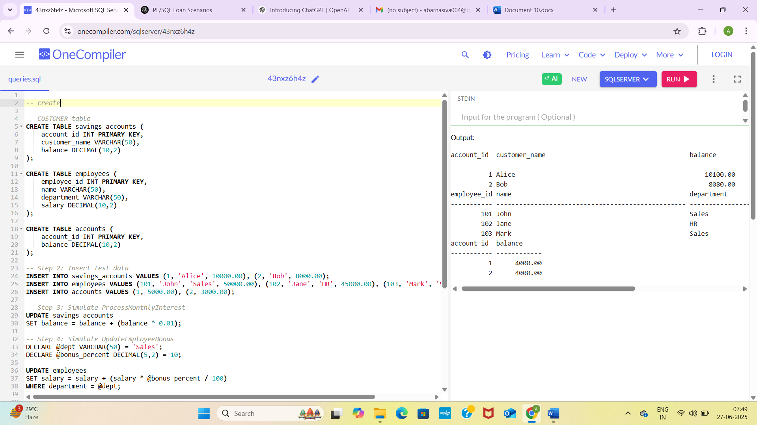4.FUNCTION:

DECLARE @dob DATE = '2000-06-01';

SELECT DATEDIFF(YEAR, @dob, GETDATE()) - CASE WHEN MONTH(@dob) > MONTH(GETDATE()) OR (MONTH(@dob) = MONTH(GETDATE()) AND DAY(@dob) > DAY(GETDATE())) THEN 1 ELSE 0 END AS Age; DECLARE @loan_amount DECIMAL(10,2) = 100000, @annual_interest_rate DECIMAL(5,2) = 12, @years INT = 5;

DECLARE @monthly_rate DECIMAL(10,6) = @annual_interest_rate / 12 / 100, @months INT = @years * 12, @emi DECIMAL(10,2);

IF @monthly_rate = 0 SET @emi = @loan_amount / @months; ELSE SET @emi = (@loan_amount * @monthly_rate * POWER(1 + @monthly_rate, @months)) / (POWER(1 + @monthly_rate, @months) - 1);

SELECT @emi AS MonthlyInstallment; CREATE TABLE accounts ( account_id INT PRIMARY KEY, balance DECIMAL(10,2) );

-- Insert test data (only once) INSERT INTO accounts VALUES (1, 10000.00), (2, 2500.00);

-- Simulate HasSufficientBalance DECLARE @acct_id INT = 1, @amount DECIMAL(10,2) = 5000, @balance DECIMAL(10,2);

SELECT @balance = balance FROM accounts WHERE account_id = @acct_id;

IF @balance IS NOT NULL AND @balance >= @amount SELECT 'TRUE' AS HasSufficientBalance; ELSE SELECT 'FALSE' AS HasSufficientBalance;

OUTPUT SCREENSHOT:

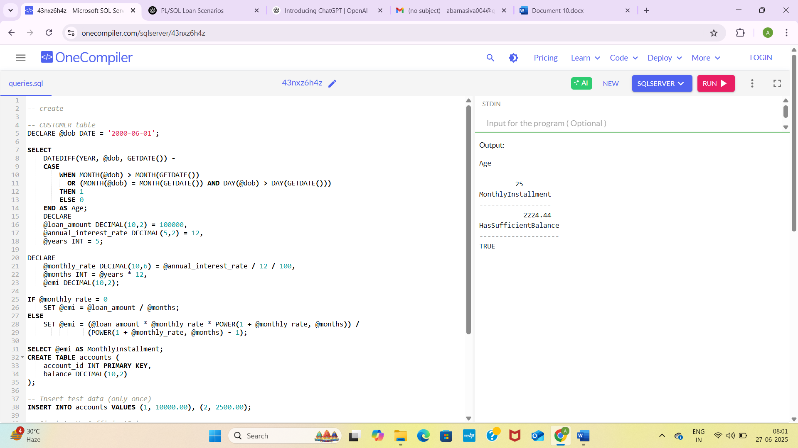6.CURSOR

CREATE TABLE Customers ( customer_id INT PRIMARY KEY, name VARCHAR(50), balance DECIMAL(10,2) );

-- Insert sample data INSERT INTO Customers VALUES (1, 'Alice', 5000); INSERT INTO Customers VALUES (2, 'Bob', 6000); INSERT INTO Customers VALUES (3, 'Charlie', 7000);

-- Cursor to apply annual fee DECLARE @cust_id INT, @cust_balance DECIMAL(10,2);

DECLARE fee_cursor CURSOR FOR SELECT customer_id, balance FROM Customers;

OPEN fee_cursor; FETCH NEXT FROM fee_cursor INTO @cust_id, @cust_balance;

WHILE @@FETCH_STATUS = 0 BEGIN -- Deduct annual fee of ₹100 UPDATE Customers SET balance = balance - 100 WHERE customer_id = @cust_id;

PRINT 'Annual fee deducted for Customer ID: ' + CAST(@cust_id AS VARCHAR);  
  
FETCH NEXT FROM fee_cursor INTO @cust_id, @cust_balance;

END

CLOSE fee_cursor; DEALLOCATE fee_cursor;

-- View updated balances SELECT * FROM Customers;

-- Create Transactions table CREATE TABLE Transactions ( txn_id INT PRIMARY KEY, customer_id INT, txn_date DATE, amount DECIMAL(10,2), txn_type VARCHAR(10) );

-- Insert sample transactions (current month) INSERT INTO Transactions VALUES (101, 1, GETDATE(), 2000, 'deposit'); INSERT INTO Transactions VALUES (102, 2, GETDATE(), 1000, 'withdrawal'); INSERT INTO Transactions VALUES (103, 3, '2023-12-15', 3000, 'deposit'); -- old transaction

-- Cursor to print this month's transactions DECLARE @txn_customer_id INT, @txn_amount DECIMAL(10,2), @txn_type VARCHAR(10), @txn_date DATE;

DECLARE monthly_cursor CURSOR FOR SELECT customer_id, txn_date, amount, txn_type FROM Transactions WHERE MONTH(txn_date) = MONTH(GETDATE()) AND YEAR(txn_date) = YEAR(GETDATE());

OPEN monthly_cursor;

FETCH NEXT FROM monthly_cursor INTO @txn_customer_id, @txn_date, @txn_amount, @txn_type;

WHILE @@FETCH_STATUS = 0 BEGIN -- Use SELECT instead of PRINT for reliable output in OneCompiler SELECT 'Customer ' + CAST(@txn_customer_id AS VARCHAR) + ' | Date: ' + CAST(@txn_date AS VARCHAR) + ' | Amount: ' + CAST(@txn_amount AS VARCHAR) + ' | Type: ' + @txn_type AS TransactionInfo;

FETCH NEXT FROM monthly_cursor INTO @txn_customer_id, @txn_date, @txn_amount, @txn_type;

END

CLOSE monthly_cursor; DEALLOCATE monthly_cursor;

-- To verify data also: SELECT * FROM Transactions;

OUTPUT SCREENSHOT:

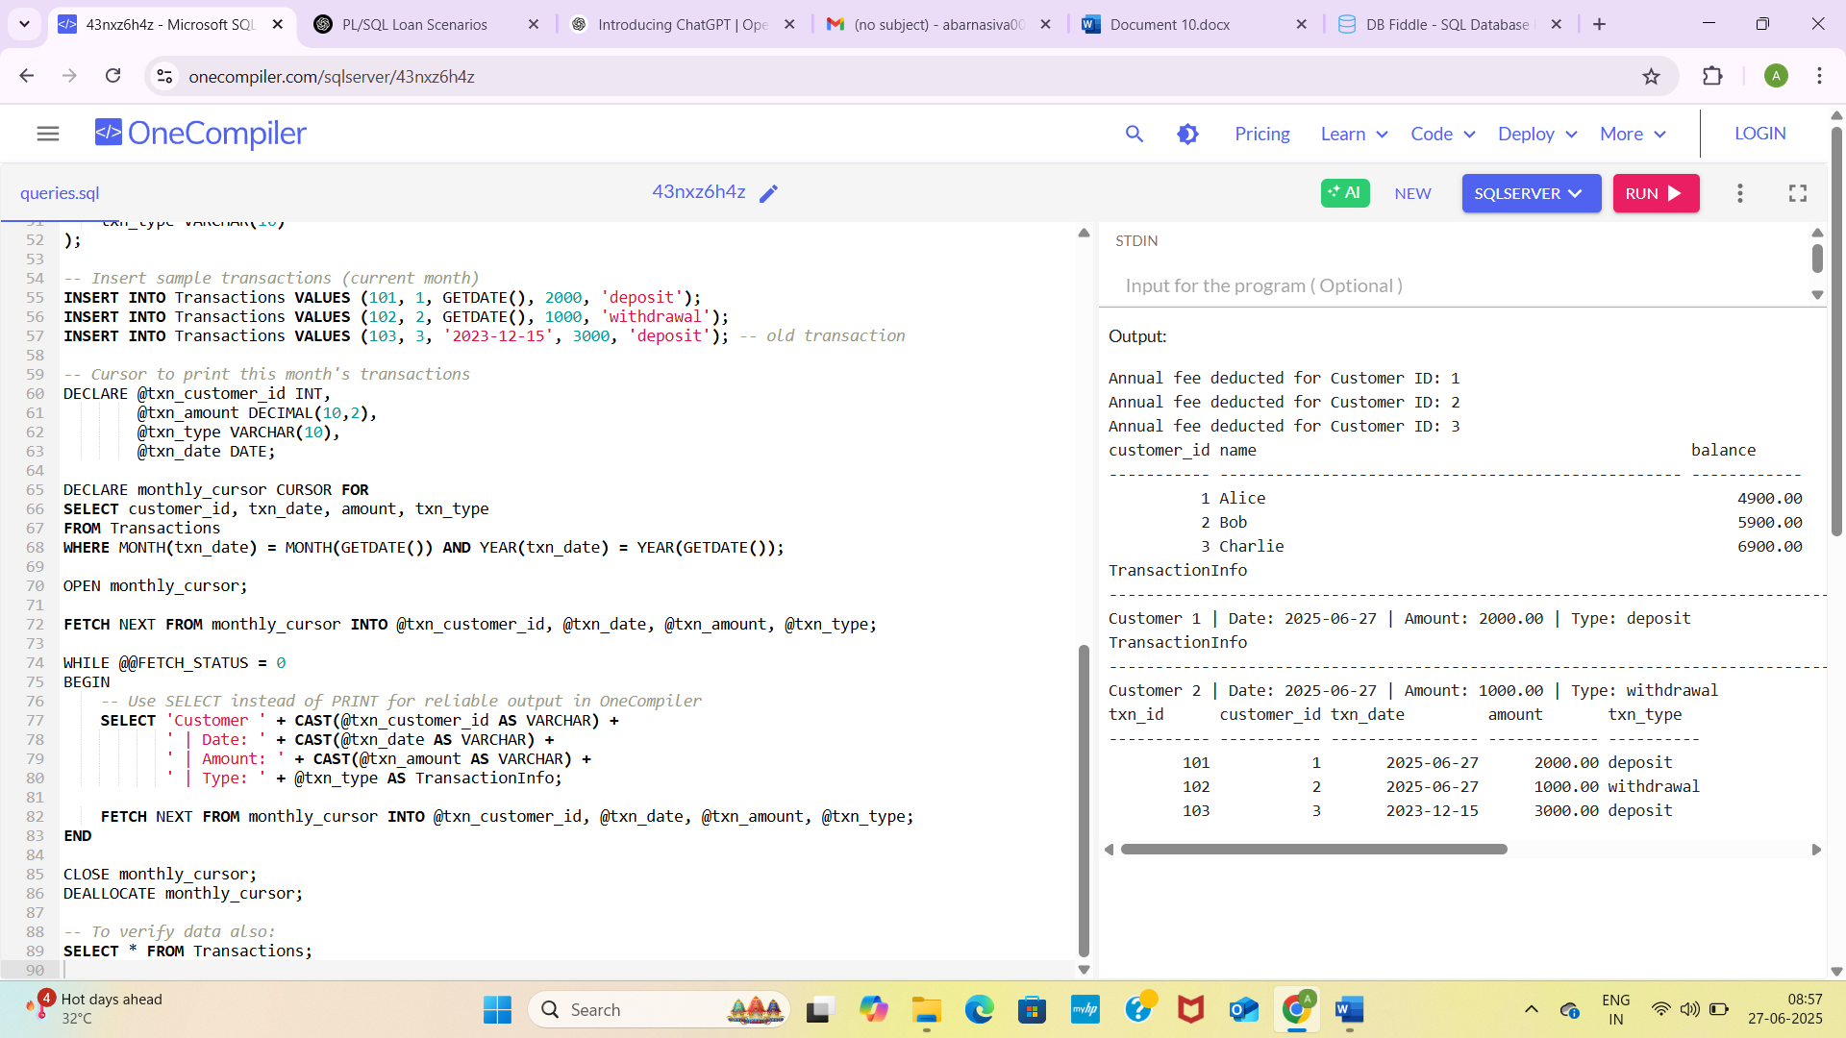7.PACKAGES:

IF OBJECT_ID('Customers', 'U') IS NOT NULL

DROP TABLE Customers;

-- Create Customers table

CREATE TABLE Customers (

CustomerID INT PRIMARY KEY,

Name VARCHAR(100),

DOB DATE,

Balance DECIMAL(10, 2),

LastModified DATETIME

);

-- Create stored procedure to add a new customer

IF OBJECT_ID('AddCustomer', 'P') IS NOT NULL

DROP PROCEDURE AddCustomer;

GO

CREATE PROCEDURE AddCustomer

@CustomerID INT,

@Name VARCHAR(100),

@DOB DATE,

@Balance DECIMAL(10,2)

AS

BEGIN

INSERT INTO Customers (CustomerID, Name, DOB, Balance, LastModified)

VALUES (@CustomerID, @Name, @DOB, @Balance, GETDATE());

END;

GO

-- Create stored procedure to update customer details

IF OBJECT_ID('UpdateCustomer', 'P') IS NOT NULL

DROP PROCEDURE UpdateCustomer;

GO

CREATE PROCEDURE UpdateCustomer

@CustomerID INT,

@Name VARCHAR(100),

@Balance DECIMAL(10,2)

AS

BEGIN

UPDATE Customers

SET Name = @Name,

Balance = @Balance,

LastModified = GETDATE()

WHERE CustomerID = @CustomerID;

END;

GO

-- Create function to get customer balance

IF OBJECT_ID('GetBalance', 'FN') IS NOT NULL

DROP FUNCTION GetBalance;

GO

CREATE FUNCTION GetBalance (@CustomerID INT)

RETURNS DECIMAL(10,2)

AS

BEGIN

DECLARE @bal DECIMAL(10,2);

SELECT @bal = Balance FROM Customers WHERE CustomerID = @CustomerID;

RETURN @bal;

END;

GO

-- ✅ Test the procedures and function

-- Add a new customer

EXEC AddCustomer 1, 'John Doe', '1990-01-01', 5000;

-- Update customer info

EXEC UpdateCustomer 1, 'John D.', 5500;

-- Get balance using the function

SELECT dbo.GetBalance(1) AS CustomerBalance;

-- View the full customer record

SELECT * FROM Customers;

OUTPUT SCREENSHOT:

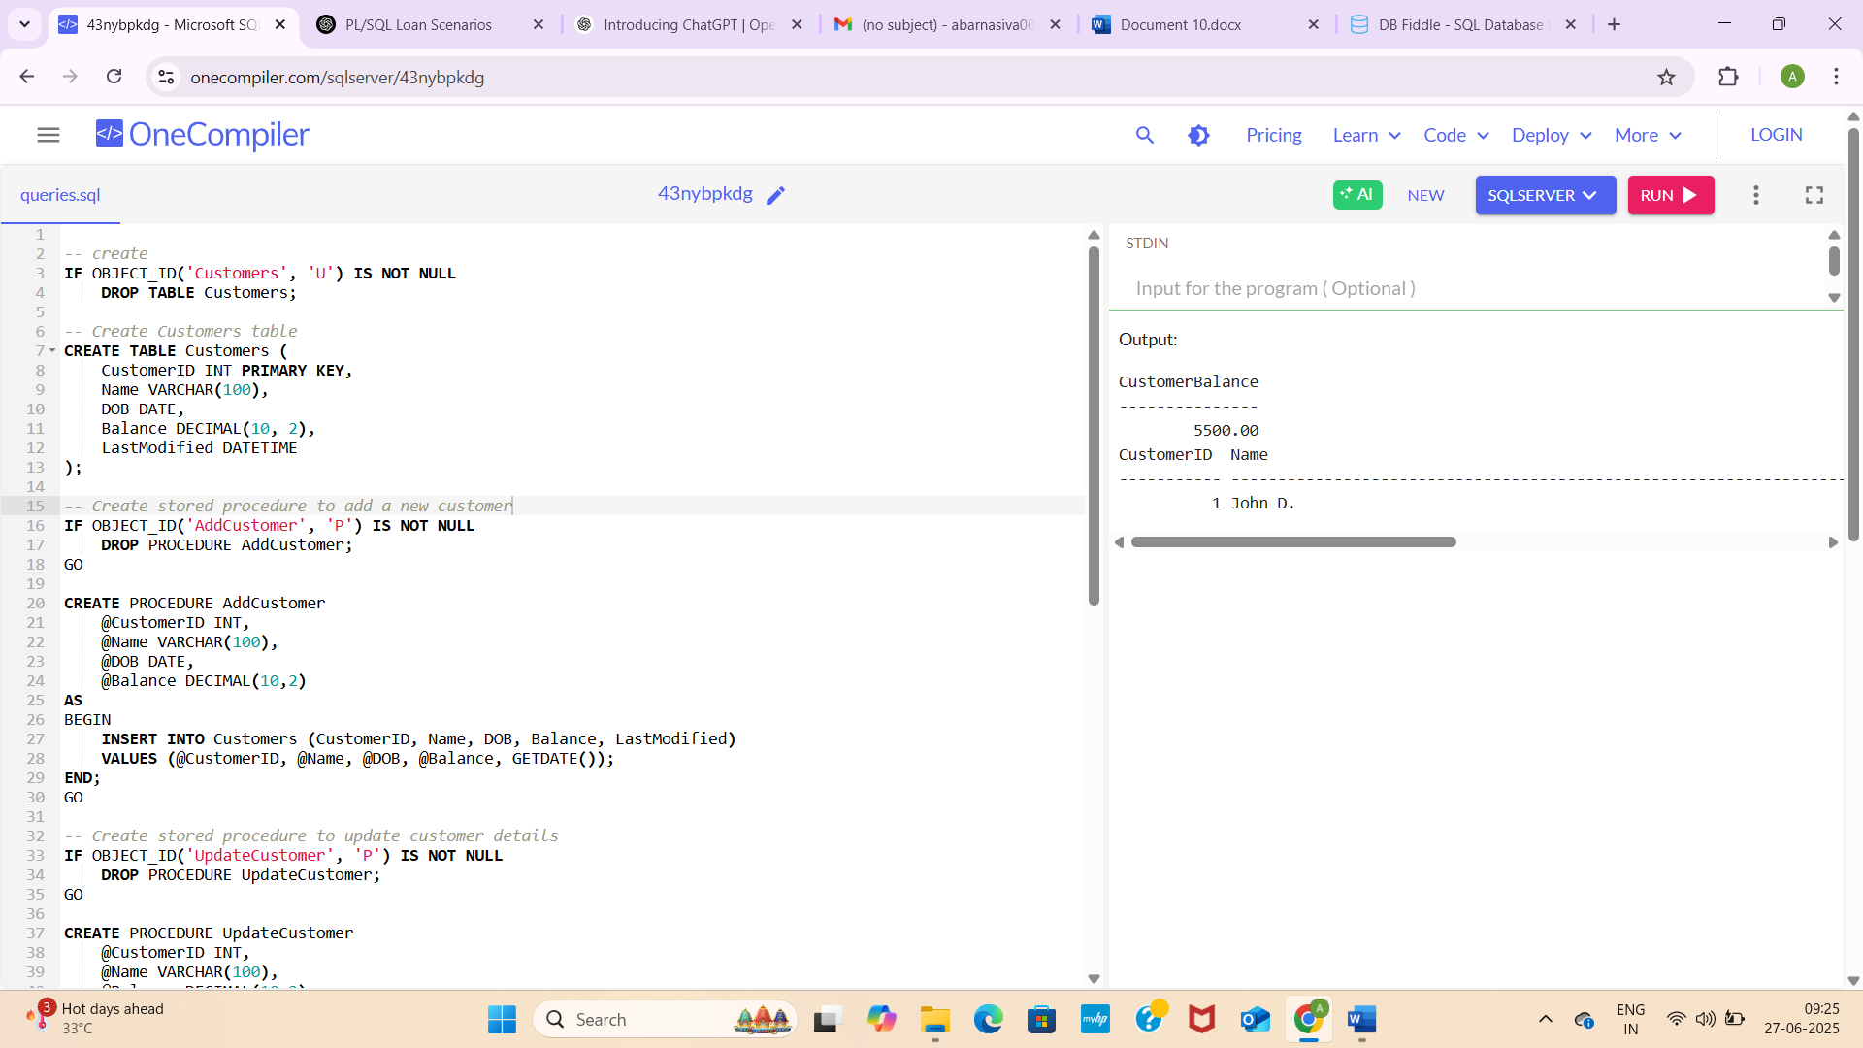

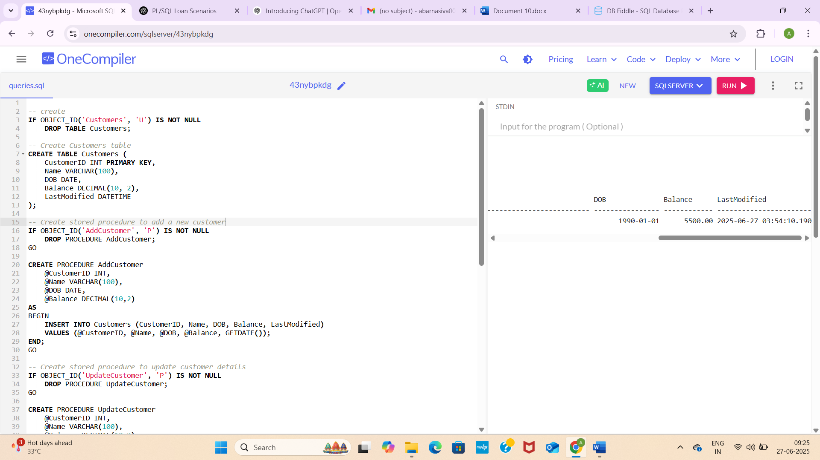1.Setting up Junit(example test)

Test class is created and and new java project in eclipse

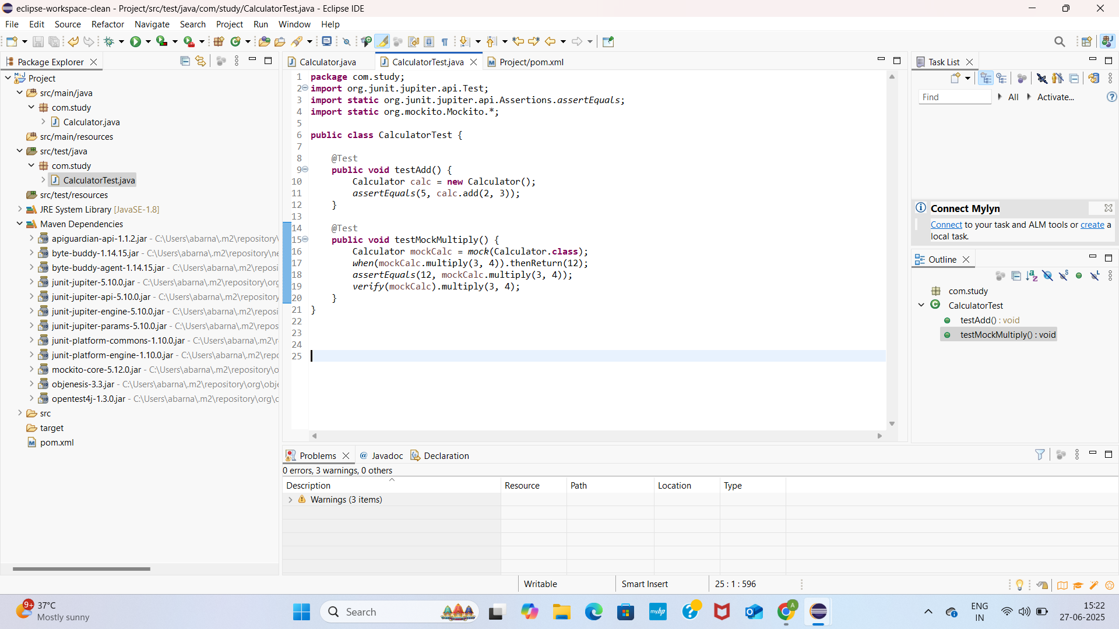

Pom.xml

<project xmlns="http://maven.apache.org/POM/4.0.0"

xmlns:xsi="http://www.w3.org/2001/XMLSchema-instance"

xsi:schemaLocation="http://maven.apache.org/POM/4.0.0

<http://maven.apache.org/xsd/maven-4.0.0.xsd>">

<modelVersion>4.0.0</modelVersion>

<groupId>com.study</groupId>

<artifactId>Project</artifactId>

<version>1.0-SNAPSHOT</version>

<properties>

<maven.compiler.source>1.8</maven.compiler.source>

<maven.compiler.target>1.8</maven.compiler.target>

<project.build.sourceEncoding>UTF-8</project.build.sourceEncoding>

</properties>

<dependencies>

<!-- ✅ JUnit 5 -->

<dependency>

<groupId>org.junit.jupiter</groupId>

<artifactId>junit-jupiter</artifactId>

<version>5.10.0</version>

<scope>test</scope>

</dependency>

<!-- ✅ Mockito -->

<dependency>

<groupId>org.mockito</groupId>

<artifactId>mockito-core</artifactId>

<version>5.12.0</version>

<scope>test</scope>

</dependency>

</dependencies>

<build>

<plugins>

<!-- Plugin to run JUnit 5 tests -->

<plugin>

<groupId>org.apache.maven.plugins</groupId>

<artifactId>maven-surefire-plugin</artifactId>

<version>3.1.2</version>

<configuration>

<useModulePath>false</useModulePath>

</configuration>

</plugin>

</plugins>

</build>

</project>

By using maven I have added it you could view in screenshot

2.Writing Basic Junit test

Calculator.java

**package** com.study;

**public** **class** Calculator {

**public** **int** add(**int** a, **int** b) {

**return** a + b;

}

**public** **int** multiply(**int** a, **int** b) {

**return** a * b;

}

}

Calculatortest.java

**package** com.study;

**import** org.junit.jupiter.api.Test;

**import** **static** org.junit.jupiter.api.Assertions.*assertEquals*;

**import** **static** org.mockito.Mockito.*;

**public** **class** CalculatorTest {

@Test

**public** **void** testAdd() {

Calculator calc = **new** Calculator();

*assertEquals*(5, calc.add(2, 3));

}

@Test

**public** **void** testMockMultiply() {

Calculator mockCalc = *mock*(Calculator.**class**);

*when*(mockCalc.multiply(3, 4)).thenReturn(12);

*assertEquals*(12, mockCalc.multiply(3, 4));

*verify*(mockCalc).multiply(3, 4);

}

}

Pom.xml

<project xmlns="http://maven.apache.org/POM/4.0.0"

xmlns:xsi="http://www.w3.org/2001/XMLSchema-instance"

xsi:schemaLocation="http://maven.apache.org/POM/4.0.0

<http://maven.apache.org/xsd/maven-4.0.0.xsd>">

<modelVersion>4.0.0</modelVersion>

<groupId>com.study</groupId>

<artifactId>Project</artifactId>

<version>1.0-SNAPSHOT</version>

<properties>

<maven.compiler.source>1.8</maven.compiler.source>

<maven.compiler.target>1.8</maven.compiler.target>

<project.build.sourceEncoding>UTF-8</project.build.sourceEncoding>

</properties>

<dependencies>

<!-- ✅ JUnit 5 -->

<dependency>

<groupId>org.junit.jupiter</groupId>

<artifactId>junit-jupiter</artifactId>

<version>5.10.0</version>

<scope>test</scope>

</dependency>

<!-- ✅ Mockito -->

<dependency>

<groupId>org.mockito</groupId>

<artifactId>mockito-core</artifactId>

<version>5.12.0</version>

<scope>test</scope>

</dependency>

</dependencies>

<build>

<plugins>

<!-- Plugin to run JUnit 5 tests -->

<plugin>

<groupId>org.apache.maven.plugins</groupId>

<artifactId>maven-surefire-plugin</artifactId>

<version>3.1.2</version>

<configuration>

<useModulePath>false</useModulePath>

</configuration>

</plugin>

</plugins>

</build>

</project>

OUTPUT SCREENSHOT:

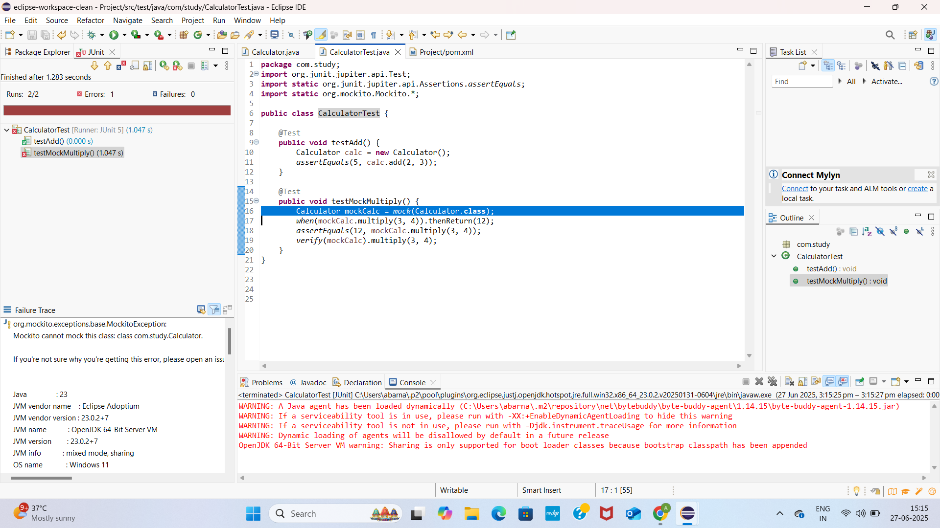3.Assertion in junit

AssertionsTest.java

**package** com.study;

**import** org.junit.jupiter.api.Test;

**import** **static** org.junit.jupiter.api.Assertions.*;

**public** **class** AssertionsTest {

@Test

**public** **void** testAssertions() {

// Assert equals

*assertEquals*(5, 2 + 3);

// Assert true

*assertTrue*(5 > 3);

// Assert false

*assertFalse*(5 < 3);

// Assert null

*assertNull*(**null**);

// Assert not null

*assertNotNull*(**new** Object());

}

}

Pom.xml

<project xmlns="http://maven.apache.org/POM/4.0.0"

xmlns:xsi="http://www.w3.org/2001/XMLSchema-instance"

xsi:schemaLocation="http://maven.apache.org/POM/4.0.0

<http://maven.apache.org/xsd/maven-4.0.0.xsd>">

<modelVersion>4.0.0</modelVersion>

<groupId>com.study</groupId>

<artifactId>Project</artifactId>

<version>1.0-SNAPSHOT</version>

<properties>

<maven.compiler.source>1.8</maven.compiler.source>

<maven.compiler.target>1.8</maven.compiler.target>

<project.build.sourceEncoding>UTF-8</project.build.sourceEncoding>

</properties>

<dependencies>

<!-- ✅ JUnit 5 -->

<dependency>

<groupId>org.junit.jupiter</groupId>

<artifactId>junit-jupiter</artifactId>

<version>5.10.0</version>

<scope>test</scope>

</dependency>

<!-- ✅ Mockito -->

<dependency>

<groupId>org.mockito</groupId>

<artifactId>mockito-core</artifactId>

<version>5.12.0</version>

<scope>test</scope>

</dependency>

</dependencies>

<build>

<plugins>

<!-- Plugin to run JUnit 5 tests -->

<plugin>

<groupId>org.apache.maven.plugins</groupId>

<artifactId>maven-surefire-plugin</artifactId>

<version>3.1.2</version>

<configuration>

<useModulePath>false</useModulePath>

</configuration>

</plugin>

</plugins>

</build>

</project>

OUTPUTSCREENSHOT:

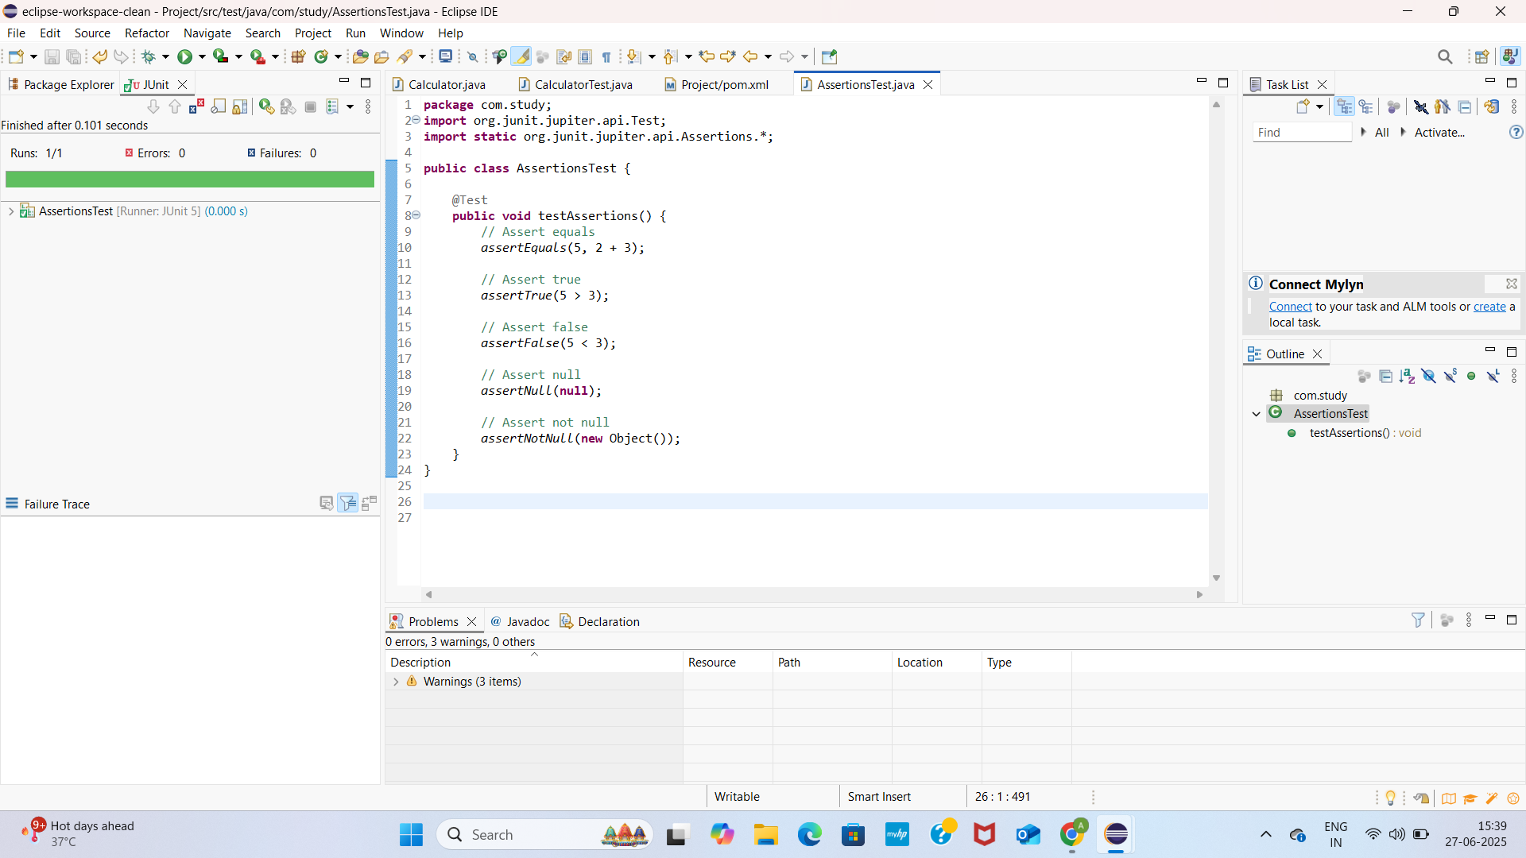4. Arrange Act Assert

CalculatorTest.java

**package** com.study;

**import** org.junit.jupiter.api.Test;

**import** **static** org.junit.jupiter.api.Assertions.*assertEquals*;

**import** **static** org.mockito.Mockito.*;

**public** **class** CalculatorTest {

@Test

**public** **void** testAdd() {

Calculator calc = **new** Calculator();

*assertEquals*(5, calc.add(2, 3));

}

@Test

**public** **void** testMockMultiply() {

Calculator mockCalc = *mock*(Calculator.**class**);

*when*(mockCalc.subtract(3, 4)).thenReturn(12);

*assertEquals*(12, mockCalc.subtract(3, 4));

*verify*(mockCalc).subtract(3, 4);

}

}

CalculatorTestLifecycle.java

**package** com.study;

**import** org.junit.jupiter.api.*;

**import** **static** org.junit.jupiter.api.Assertions.*;

**public** **class** CalculatorLifecycleTest {

**private** Calculator calc; // Declare calc globally (class-level)

@BeforeEach

**public** **void** setUp() {

calc = **new** Calculator(); // Initialize it before each test

}

@AfterEach

**public** **void** tearDown() {

calc = **null**; // Clean up

}

@Test

**public** **void** testAdd() {

**int** result = calc.add(2, 3);

*assertEquals*(5, result);

}

@Test

**public** **void** testSubtract() {

**int** result = calc.subtract(10, 4);

*assertEquals*(6, result);

}

}

OUTPUTSCREENSHOT

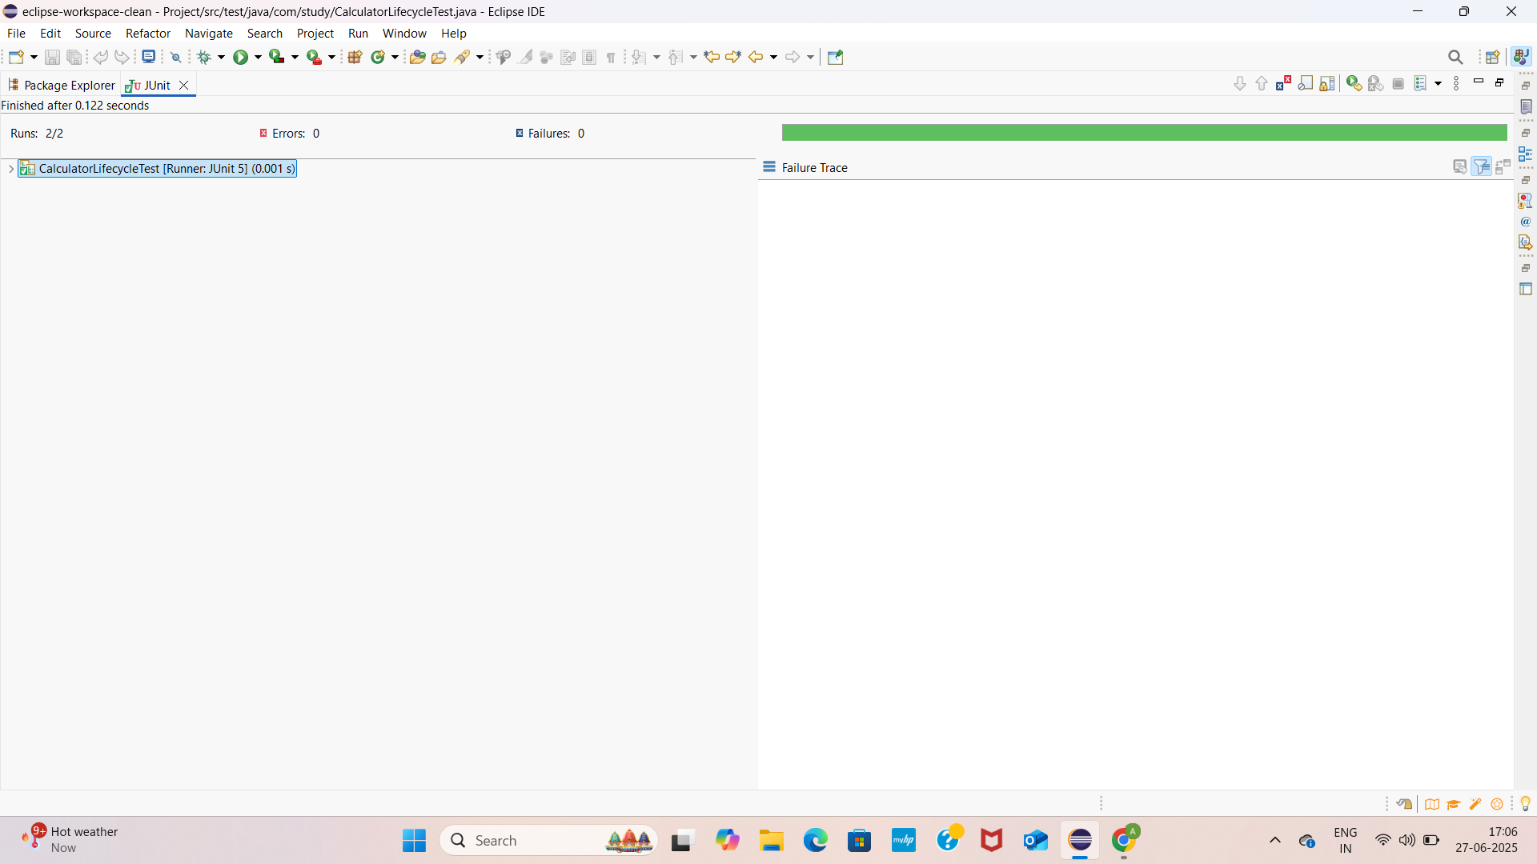ADVANCED JUNIT TESTING EXERCISES

1.PARAMETERIZED TEST

EvenChecker.java

**package** com.study;

**public** **class** EvenChecker {

**public** **boolean** isEven(**int** number) {

**return** number % 2 == 0;

}

}

EvenCheckerTest.java

**package** com.study;

**import** org.junit.jupiter.params.ParameterizedTest;

**import** org.junit.jupiter.params.provider.ValueSource;

**import** **static** org.junit.jupiter.api.Assertions.*;

**public** **class** EvenCheckerTest {

**private** **final** EvenChecker checker = **new** EvenChecker();

@ParameterizedTest

@ValueSource(ints = {2, 4, 6, 10, 100})

**public** **void** testEvenNumbers(**int** number) {

*assertTrue*(checker.isEven(number), number + " should be even");

}

@ParameterizedTest

@ValueSource(ints = {1, 3, 5, 9, 101})

**public** **void** testOddNumbers(**int** number) {

*assertFalse*(checker.isEven(number), number + " should be odd");

}

}

Pom.xml

<project xmlns="http://maven.apache.org/POM/4.0.0"

xmlns:xsi="http://www.w3.org/2001/XMLSchema-instance"

xsi:schemaLocation="http://maven.apache.org/POM/4.0.0

<http://maven.apache.org/xsd/maven-4.0.0.xsd>">

<modelVersion>4.0.0</modelVersion>

<groupId>com.study</groupId>

<artifactId>Project</artifactId>

<version>1.0-SNAPSHOT</version>

<properties>

<maven.compiler.source>1.8</maven.compiler.source>

<maven.compiler.target>1.8</maven.compiler.target>

<project.build.sourceEncoding>UTF-8</project.build.sourceEncoding>

</properties>

<dependencies>

<!-- ✅ JUnit 5 -->

<dependency>

<groupId>org.junit.jupiter</groupId>

<artifactId>junit-jupiter</artifactId>

<version>5.10.0</version>

<scope>test</scope>

</dependency>

<!-- ✅ Mockito -->

<dependency>

<groupId>org.mockito</groupId>

<artifactId>mockito-core</artifactId>

<version>5.12.0</version>

<scope>test</scope>

</dependency>

</dependencies>

<build>

<plugins>

<!-- Plugin to run JUnit 5 tests -->

<plugin>

<groupId>org.apache.maven.plugins</groupId>

<artifactId>maven-surefire-plugin</artifactId>

<version>3.1.2</version>

<configuration>

<useModulePath>false</useModulePath>

</configuration>

</plugin>

</plugins>

</build>

</project>

OUTPUTSCREENSHOT

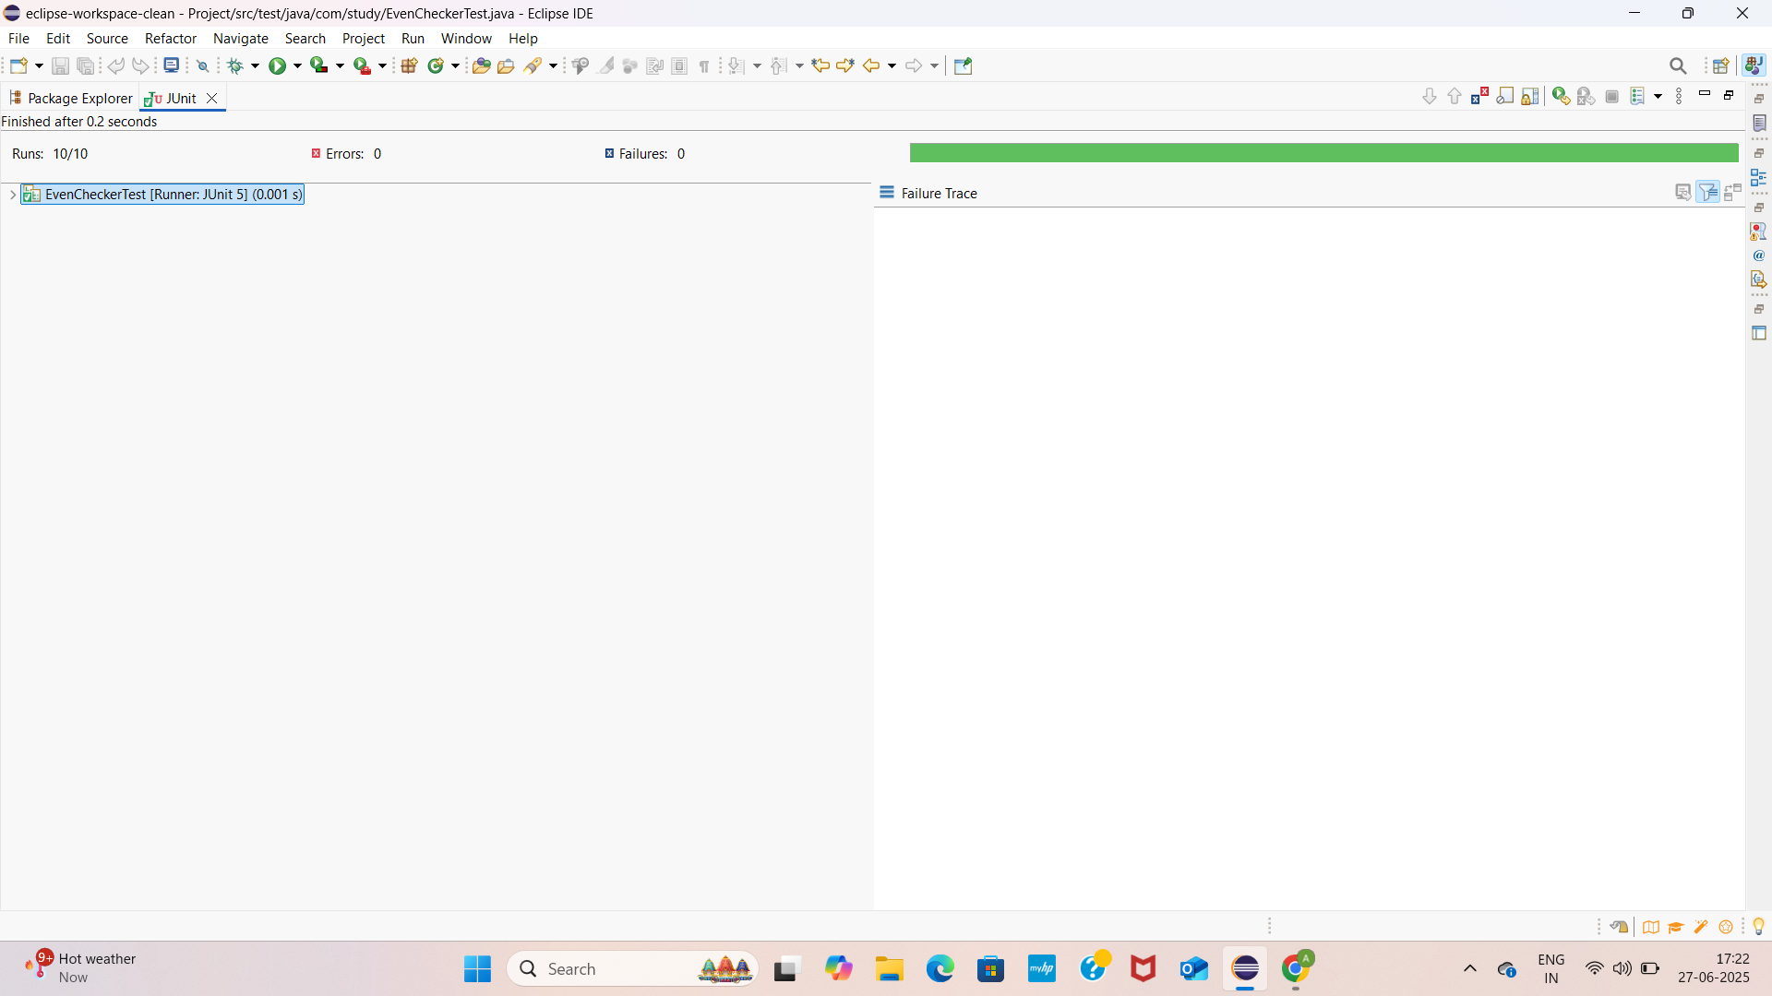2.Test Suites and categories

AllTests.java

**package** com.study;

**import** org.junit.jupiter.api.Assertions;

**public** **class** AllTests {

**public** **static** **void** main(String[] args) {

CalculatorLifecycleTest calculatorTest = **new** CalculatorLifecycleTest();

EvenCheckerTest evenCheckerTest = **new** EvenCheckerTest();

// Manually call each test (setup not called automatically)

**try** {

calculatorTest.setUp();

calculatorTest.testAdd();

calculatorTest.testSubtract();

calculatorTest.tearDown();

evenCheckerTest.testEvenNumbers(2);

evenCheckerTest.testEvenNumbers(4);

evenCheckerTest.testEvenNumbers(6);

evenCheckerTest.testEvenNumbers(10);

evenCheckerTest.testEvenNumbers(100);

evenCheckerTest.testOddNumbers(1);

evenCheckerTest.testOddNumbers(3);

evenCheckerTest.testOddNumbers(5);

evenCheckerTest.testOddNumbers(9);

evenCheckerTest.testOddNumbers(101);

System.***out***.println("✅ All tests passed manually!");

} **catch** (AssertionError | Exception e) {

System.***out***.println("❌ Test failed: " + e.getMessage());

}

}

}

EvenChecker.java

**package** com.study;

**public** **class** EvenChecker {

**public** **boolean** isEven(**int** number) {

**return** number % 2 == 0;

}

}

CalculatorLifecycleTest.java

**package** com.study;

**import** org.junit.jupiter.api.*;

**import** **static** org.junit.jupiter.api.Assertions.*;

@Tag("math")

**public** **class** CalculatorLifecycleTest {

**private** Calculator calc; // Declare calc globally (class-level)

@BeforeEach

**public** **void** setUp() {

calc = **new** Calculator(); // Initialize it before each test

}

@AfterEach

**public** **void** tearDown() {

calc = **null**; // Clean up

}

@Test

**public** **void** testAdd() {

**int** result = calc.add(2, 3);

*assertEquals*(5, result,"Addition failed");

}

@Test

**public** **void** testSubtract() {

**int** result = calc.subtract(10, 4);

*assertEquals*(6, result,"Subtraction failed");

}

}

Pom.xml

<project xmlns="http://maven.apache.org/POM/4.0.0"

xmlns:xsi="http://www.w3.org/2001/XMLSchema-instance"

xsi:schemaLocation="http://maven.apache.org/POM/4.0.0

<http://maven.apache.org/xsd/maven-4.0.0.xsd>">

<modelVersion>4.0.0</modelVersion>

<groupId>com.study</groupId>

<artifactId>Project</artifactId>

<version>1.0-SNAPSHOT</version>

<properties>

<maven.compiler.source>1.8</maven.compiler.source>

<maven.compiler.target>1.8</maven.compiler.target>

<project.build.sourceEncoding>UTF-8</project.build.sourceEncoding>

</properties>

<dependencies>

<!-- ✅ JUnit 5 -->

<dependency>

<groupId>org.junit.jupiter</groupId>

<artifactId>junit-jupiter</artifactId>

<version>5.10.0</version>

<scope>test</scope>

</dependency>

<!-- ✅ Mockito -->

<dependency>

<groupId>org.mockito</groupId>

<artifactId>mockito-core</artifactId>

<version>5.12.0</version>

<scope>test</scope>

</dependency>

</dependencies>

<build>

<plugins>

<!-- Plugin to run JUnit 5 tests -->

<plugin>

<groupId>org.apache.maven.plugins</groupId>

<artifactId>maven-surefire-plugin</artifactId>

<version>3.1.2</version>

<configuration>

<useModulePath>false</useModulePath>

</configuration>

</plugin>

</plugins>

</build>

</project>

Output screenshot

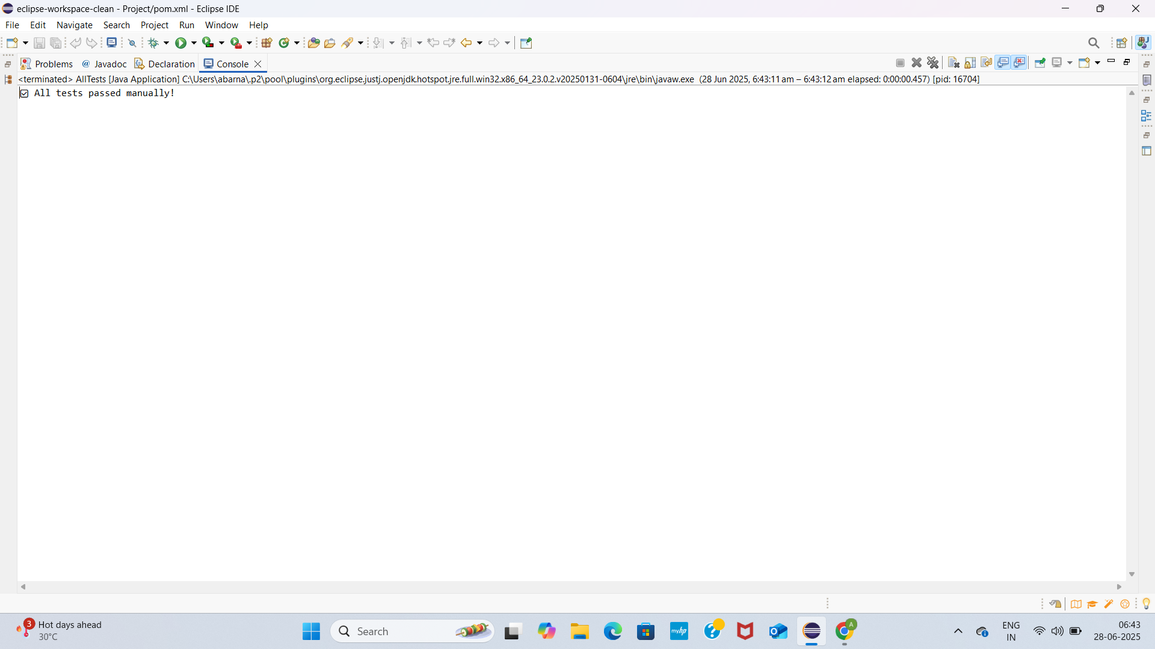3.Test Execution Order

OrderedTest.java

**package** com.study;

**import** org.junit.jupiter.api.*;

**import** org.junit.jupiter.api.MethodOrderer.OrderAnnotation;

@TestMethodOrder(OrderAnnotation.**class**) // Tell JUnit to use @Order

**public** **class** OrderedTests {

@Test

@Order(1)

**void** testFirst() {

System.***out***.println("Running testFirst()");

}

@Test

@Order(3)

**void** testThird() {

System.***out***.println("Running testThird()");

}

@Test

@Order(2)

**void** testSecond() {

System.***out***.println("Running testSecond()");

}

}

Pom.xml

<project xmlns="http://maven.apache.org/POM/4.0.0"

xmlns:xsi="http://www.w3.org/2001/XMLSchema-instance"

xsi:schemaLocation="http://maven.apache.org/POM/4.0.0

<http://maven.apache.org/xsd/maven-4.0.0.xsd>">

<modelVersion>4.0.0</modelVersion>

<groupId>com.study</groupId>

<artifactId>Project</artifactId>

<version>1.0-SNAPSHOT</version>

<properties>

<maven.compiler.source>1.8</maven.compiler.source>

<maven.compiler.target>1.8</maven.compiler.target>

<project.build.sourceEncoding>UTF-8</project.build.sourceEncoding>

</properties>

<dependencies>

<!-- ✅ JUnit 5 -->

<dependency>

<groupId>org.junit.jupiter</groupId>

<artifactId>junit-jupiter</artifactId>

<version>5.10.0</version>

<scope>test</scope>

</dependency>

<!-- ✅ Mockito -->

<dependency>

<groupId>org.mockito</groupId>

<artifactId>mockito-core</artifactId>

<version>5.12.0</version>

<scope>test</scope>

</dependency>

</dependencies>

<build>

<plugins>

<!-- Plugin to run JUnit 5 tests -->

<plugin>

<groupId>org.apache.maven.plugins</groupId>

<artifactId>maven-surefire-plugin</artifactId>

<version>3.1.2</version>

<configuration>

<useModulePath>false</useModulePath>

</configuration>

</plugin>

</plugins>

</build>

</project>

OUTPUT SCREENSHOT:

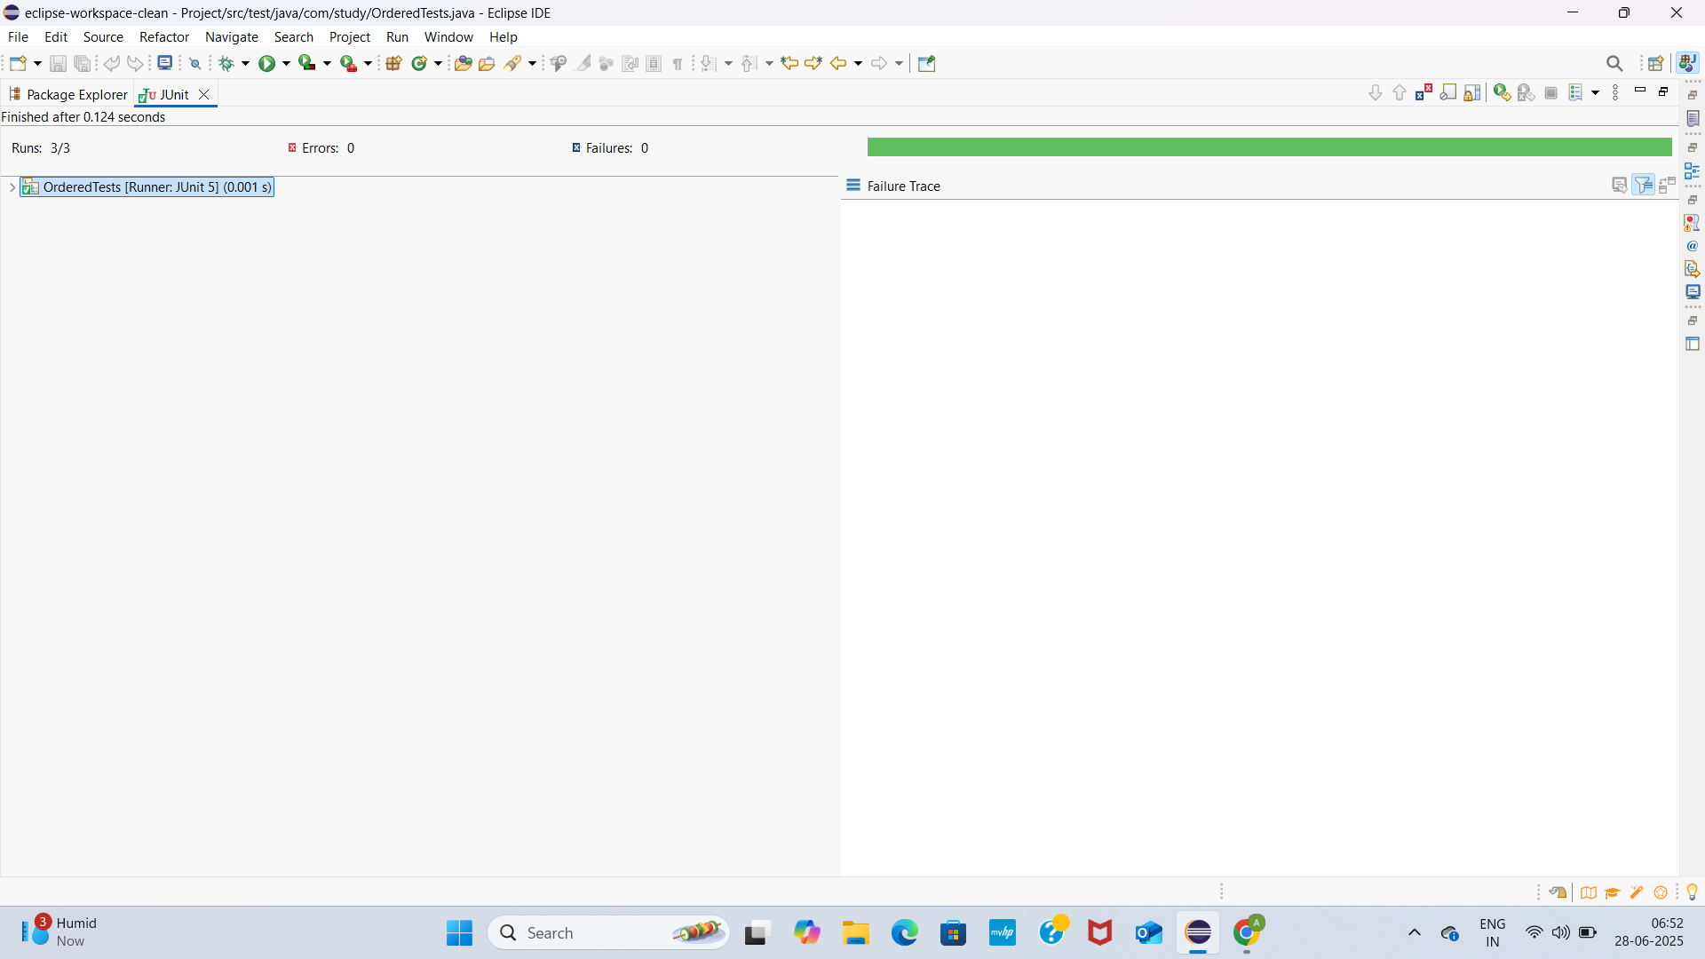4.Exception Testing

ExceptionThrowerTest.java

**package** com.study;

**import** org.junit.jupiter.api.Test;

**import** **static** org.junit.jupiter.api.Assertions.*;

**public** **class** ExceptionThrowerTest {

@Test

**void** testThrowException_whenInputIsNull_shouldThrowException() {

ExceptionThrower thrower = **new** ExceptionThrower();

Exception exception = *assertThrows*(IllegalArgumentException.**class**, () -> {

thrower.throwException(**null**);

});

*assertEquals*("Input cannot be null or empty", exception.getMessage());

}

@Test

**void** testThrowException_whenInputIsEmpty_shouldThrowException() {

ExceptionThrower thrower = **new** ExceptionThrower();

Exception exception = *assertThrows*(IllegalArgumentException.**class**, () -> {

thrower.throwException("");

});

ExceptionThrower.java

**package** com.study;

**public** **class** ExceptionThrower {

**public** **void** throwException(String input) {

**if** (input == **null** || input.isEmpty()) {

**throw** **new** IllegalArgumentException("Input cannot be null or empty");

}

// else logic here

}

}

*assertEquals*("Input cannot be null or empty", exception.getMessage());

}

}

Pom.xml

<project xmlns="http://maven.apache.org/POM/4.0.0"

xmlns:xsi="http://www.w3.org/2001/XMLSchema-instance"

xsi:schemaLocation="http://maven.apache.org/POM/4.0.0

<http://maven.apache.org/xsd/maven-4.0.0.xsd>">

<modelVersion>4.0.0</modelVersion>

<groupId>com.study</groupId>

<artifactId>Project</artifactId>

<version>1.0-SNAPSHOT</version>

<properties>

<maven.compiler.source>1.8</maven.compiler.source>

<maven.compiler.target>1.8</maven.compiler.target>

<project.build.sourceEncoding>UTF-8</project.build.sourceEncoding>

</properties>

<dependencies>

<!-- ✅ JUnit 5 -->

<dependency>

<groupId>org.junit.jupiter</groupId>

<artifactId>junit-jupiter</artifactId>

<version>5.10.0</version>

<scope>test</scope>

</dependency>

<!-- ✅ Mockito -->

<dependency>

<groupId>org.mockito</groupId>

<artifactId>mockito-core</artifactId>

<version>5.12.0</version>

<scope>test</scope>

</dependency>

</dependencies>

<build>

<plugins>

<!-- Plugin to run JUnit 5 tests -->

<plugin>

<groupId>org.apache.maven.plugins</groupId>

<artifactId>maven-surefire-plugin</artifactId>

<version>3.1.2</version>

<configuration>

<useModulePath>false</useModulePath>

</configuration>

</plugin>

</plugins>

</build>

</project>

OUTPUTSCREENSHOT

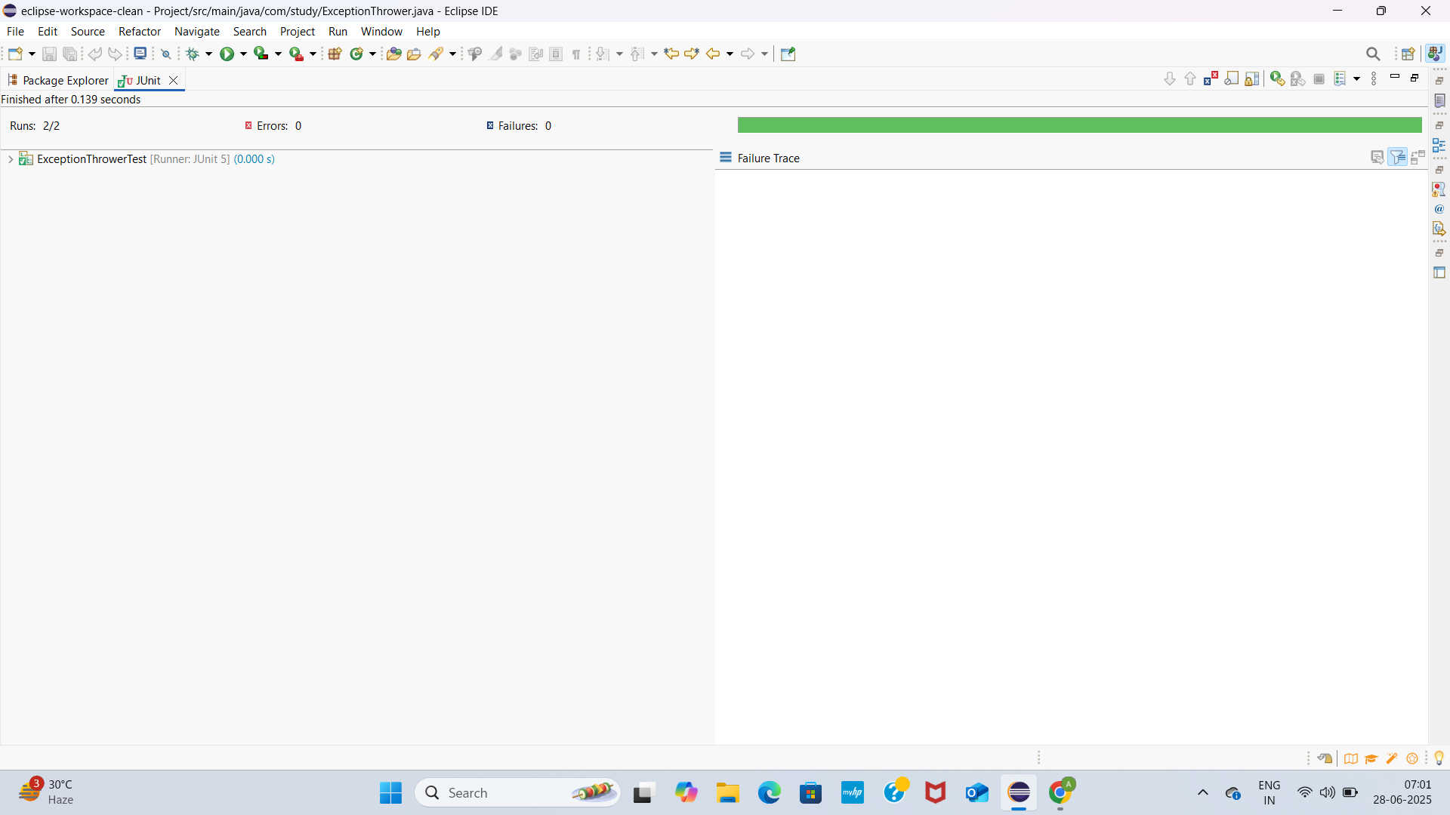

5.TIMEOUT AND PERFORMANCE TESTING

PerformanceTesterTest.java

**package** com.study;

**import** org.junit.jupiter.api.Test;

**import** **static** org.junit.jupiter.api.Assertions.*assertTimeout*;

**import** java.time.Duration;

**public** **class** PerformanceTesterTest {

@Test

**void** testPerformTaskCompletesWithin500Milliseconds() {

PerformanceTester tester = **new** PerformanceTester();

// Assert that performTask() completes within 500 milliseconds

*assertTimeout*(Duration.*ofMillis*(500), tester::performTask);

}

}

PerformanceTester.java

**package** com.study;

**public** **class** PerformanceTester {

**public** **void** performTask() {

// Simulate a task that takes time (e.g., 300 milliseconds)

**try** {

Thread.*sleep*(300);

} **catch** (InterruptedException e) {

Thread.*currentThread*().interrupt(); // good practice

}

}

}

Pom.xml

<project xmlns="http://maven.apache.org/POM/4.0.0"

xmlns:xsi="http://www.w3.org/2001/XMLSchema-instance"

xsi:schemaLocation="http://maven.apache.org/POM/4.0.0

<http://maven.apache.org/xsd/maven-4.0.0.xsd>">

<modelVersion>4.0.0</modelVersion>

<groupId>com.study</groupId>

<artifactId>Project</artifactId>

<version>1.0-SNAPSHOT</version>

<properties>

<maven.compiler.source>1.8</maven.compiler.source>

<maven.compiler.target>1.8</maven.compiler.target>

<project.build.sourceEncoding>UTF-8</project.build.sourceEncoding>

</properties>

<dependencies>

<!-- ✅ JUnit 5 -->

<dependency>

<groupId>org.junit.jupiter</groupId>

<artifactId>junit-jupiter</artifactId>

<version>5.10.0</version>

<scope>test</scope>

</dependency>

<!-- ✅ Mockito -->

<dependency>

<groupId>org.mockito</groupId>

<artifactId>mockito-core</artifactId>

<version>5.12.0</version>

<scope>test</scope>

</dependency>

</dependencies>

<build>

<plugins>

<!-- Plugin to run JUnit 5 tests -->

<plugin>

<groupId>org.apache.maven.plugins</groupId>

<artifactId>maven-surefire-plugin</artifactId>

<version>3.1.2</version>

<configuration>

<useModulePath>false</useModulePath>

</configuration>

</plugin>

</plugins>

</build>

</project>

OUTPUT SCREENSHOT

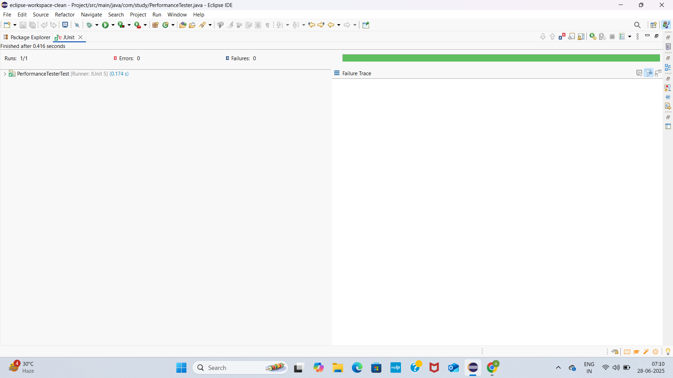MOCKITO HANDS ON

1.MOCKING AND STUBBING:

MyServiceTest.java

**package** com.study;

**import** **static** org.mockito.Mockito.*;

**import** **static** org.junit.jupiter.api.Assertions.*;

**import** org.junit.jupiter.api.Test;

**import** org.mockito.Mockito;

**public** **class** MyServiceTest {

@Test

**public** **void** testExternalApi() {

// Step 1: Create a mock object

ExternalApi mockApi = Mockito.*mock*(ExternalApi.**class**);

// Step 2: Stub the method

*when*(mockApi.getData()).thenReturn("Mock Data");

// Step 3: Inject mock into the service and test

MyService service = **new** MyService(mockApi);

String result = service.fetchData();

// Assert that mock data is returned

*assertEquals*("Mock Data", result);

}

}

MyService.java

**package** com.study;

**public** **class** MyService {

**private** ExternalApi externalApi;

**public** MyService(ExternalApi externalApi) {

**this**.externalApi = externalApi;

}

**public** String fetchData() {

**return** externalApi.getData(); // Calls the real or mocked API

}

}

ExternalApi.java

**package** com.study;

**public** **interface** ExternalApi {

String getData();

}

Pom.xml

<project xmlns="http://maven.apache.org/POM/4.0.0"

xmlns:xsi="http://www.w3.org/2001/XMLSchema-instance"

xsi:schemaLocation="http://maven.apache.org/POM/4.0.0

<http://maven.apache.org/xsd/maven-4.0.0.xsd>">

<modelVersion>4.0.0</modelVersion>

<groupId>com.study</groupId>

<artifactId>Project</artifactId>

<version>1.0-SNAPSHOT</version>

<properties>

<maven.compiler.source>1.8</maven.compiler.source>

<maven.compiler.target>1.8</maven.compiler.target>

<project.build.sourceEncoding>UTF-8</project.build.sourceEncoding>

</properties>

<dependencies>

<!-- ✅ JUnit 5 -->

<dependency>

<groupId>org.junit.jupiter</groupId>

<artifactId>junit-jupiter</artifactId>

<version>5.10.0</version>

<scope>test</scope>

</dependency>

<!-- ✅ Mockito -->

<dependency>

<groupId>org.mockito</groupId>

<artifactId>mockito-core</artifactId>

<version>5.12.0</version>

<scope>test</scope>

</dependency>

</dependencies>

<build>

<plugins>

<!-- Plugin to run JUnit 5 tests -->

<plugin>

<groupId>org.apache.maven.plugins</groupId>

<artifactId>maven-surefire-plugin</artifactId>

<version>3.1.2</version>

<configuration>

<useModulePath>false</useModulePath>

</configuration>

</plugin>

</plugins>

</build>

</project>

OUTPUT SCREENSHOT

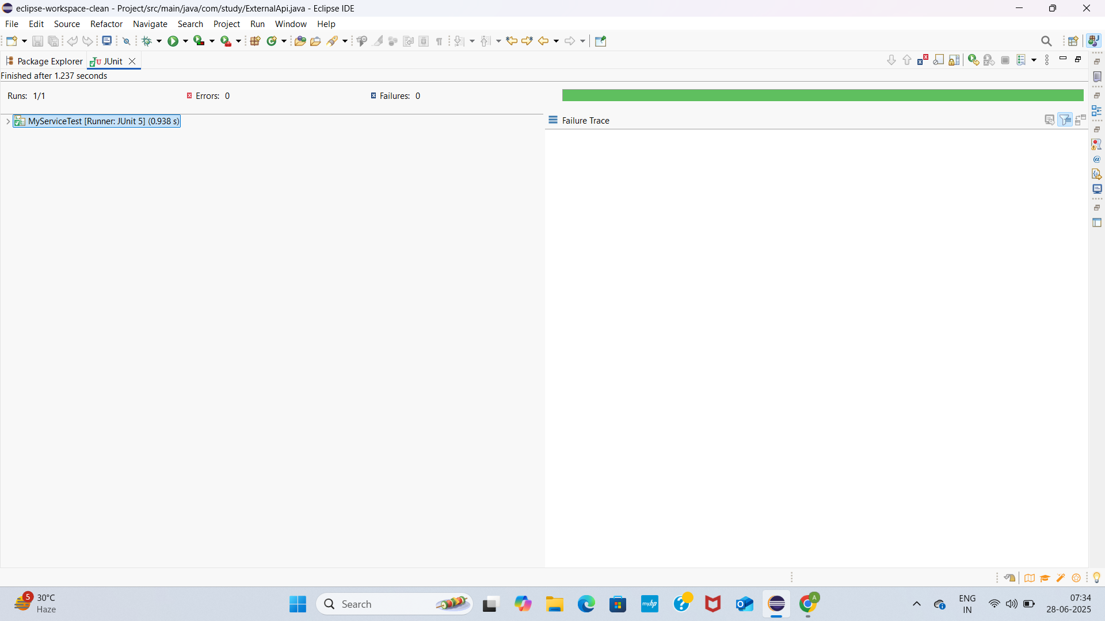

MyServiceTest.java

**package** com.study;

**import** **static** org.mockito.Mockito.*;

**import** org.junit.jupiter.api.Test;

**import** org.mockito.Mockito;

**public** **class** MyServiceTest {

@Test

**public** **void** testVerifyInteraction() {

// Step 1: Create a mock object

ExternalApi mockApi = Mockito.*mock*(ExternalApi.**class**);

MyService service = **new** MyService(mockApi);

service.fetchData();

*verify*(mockApi).getData();

}

}

MyService.java

**package** com.study;

**public** **class** MyService {

**private** ExternalApi externalApi;

**public** MyService(ExternalApi externalApi) {

**this**.externalApi = externalApi;

}

**public** String fetchData() {

**return** externalApi.getData(); // Calls the real or mocked API

}

}

ExternalApi.java

**package** com.study;

**public** **interface** ExternalApi {

String getData();

}

Pom.xml

<project xmlns="http://maven.apache.org/POM/4.0.0"

xmlns:xsi="http://www.w3.org/2001/XMLSchema-instance"

xsi:schemaLocation="http://maven.apache.org/POM/4.0.0

<http://maven.apache.org/xsd/maven-4.0.0.xsd>">

<modelVersion>4.0.0</modelVersion>

<groupId>com.study</groupId>

<artifactId>Project</artifactId>

<version>1.0-SNAPSHOT</version>

<properties>

<maven.compiler.source>1.8</maven.compiler.source>

<maven.compiler.target>1.8</maven.compiler.target>

<project.build.sourceEncoding>UTF-8</project.build.sourceEncoding>

</properties>

<dependencies>

<!-- ✅ JUnit 5 -->

<dependency>

<groupId>org.junit.jupiter</groupId>

<artifactId>junit-jupiter</artifactId>

<version>5.10.0</version>

<scope>test</scope>

</dependency>

<!-- ✅ Mockito -->

<dependency>

<groupId>org.mockito</groupId>

<artifactId>mockito-core</artifactId>

<version>5.12.0</version>

<scope>test</scope>

</dependency>

</dependencies>

<build>

<plugins>

<!-- Plugin to run JUnit 5 tests -->

<plugin>

<groupId>org.apache.maven.plugins</groupId>

<artifactId>maven-surefire-plugin</artifactId>

<version>3.1.2</version>

<configuration>

<useModulePath>false</useModulePath>

</configuration>

</plugin>

</plugins>

</build>

</project>

OUTPUTSCREENSHOT

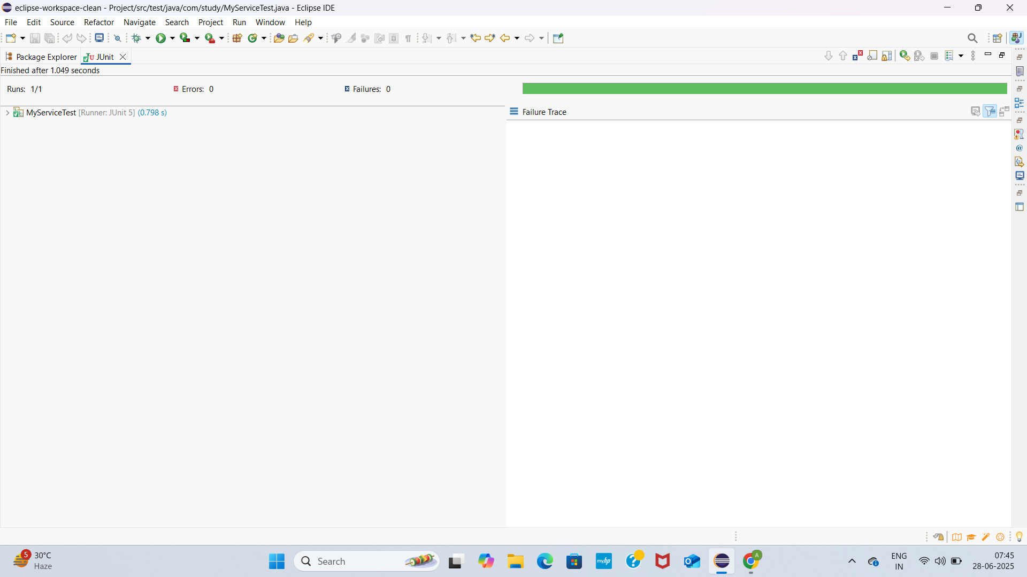3.ARGUMENT MATCHING

MyServiceTest.java

**package** com.study;

**import** **static** org.mockito.Mockito.*;

**import** **static** org.mockito.ArgumentMatchers.*;

**import** org.junit.jupiter.api.Test;

**import** org.mockito.Mockito;

**public** **class** MyServiceTest {

@Test

**public** **void** testArgumentMatching() {

// Step 1: Create mock

ExternalApi mockApi = Mockito.*mock*(ExternalApi.**class**);

// Step 2: Inject mock and call method with specific argument

MyService service = **new** MyService(mockApi);

service.process("Hello World");

// Step 3: Verify it was called with specific argument using matcher

*verify*(mockApi).sendData(*eq*("Hello World")); // ✅ Exact match

// You could also match any string like:

// verify(mockApi).sendData(anyString());

}

}

MyService.java

**package** com.study;

**public** **class** MyService {

**private** ExternalApi externalApi;

**public** MyService(ExternalApi externalApi) {

**this**.externalApi = externalApi;

}

**public** **void** process(String input) {

externalApi.sendData(input);

}

}

ExternalApi

**package** com.study;

**public** **interface** ExternalApi {

String sendData(String message);

}

Pom.xml

<project xmlns="http://maven.apache.org/POM/4.0.0"

xmlns:xsi="http://www.w3.org/2001/XMLSchema-instance"

xsi:schemaLocation="http://maven.apache.org/POM/4.0.0

<http://maven.apache.org/xsd/maven-4.0.0.xsd>">

<modelVersion>4.0.0</modelVersion>

<groupId>com.study</groupId>

<artifactId>Project</artifactId>

<version>1.0-SNAPSHOT</version>

<properties>

<maven.compiler.source>1.8</maven.compiler.source>

<maven.compiler.target>1.8</maven.compiler.target>

<project.build.sourceEncoding>UTF-8</project.build.sourceEncoding>

</properties>

<dependencies>

<!-- ✅ JUnit 5 -->

<dependency>

<groupId>org.junit.jupiter</groupId>

<artifactId>junit-jupiter</artifactId>

<version>5.10.0</version>

<scope>test</scope>

</dependency>

<!-- ✅ Mockito -->

<dependency>

<groupId>org.mockito</groupId>

<artifactId>mockito-core</artifactId>

<version>5.12.0</version>

<scope>test</scope>

</dependency>

</dependencies>

<build>

<plugins>

<!-- Plugin to run JUnit 5 tests -->

<plugin>

<groupId>org.apache.maven.plugins</groupId>

<artifactId>maven-surefire-plugin</artifactId>

<version>3.1.2</version>

<configuration>

<useModulePath>false</useModulePath>

</configuration>

</plugin>

</plugins>

</build>

</project>

OUTPUTSCREENSHOT

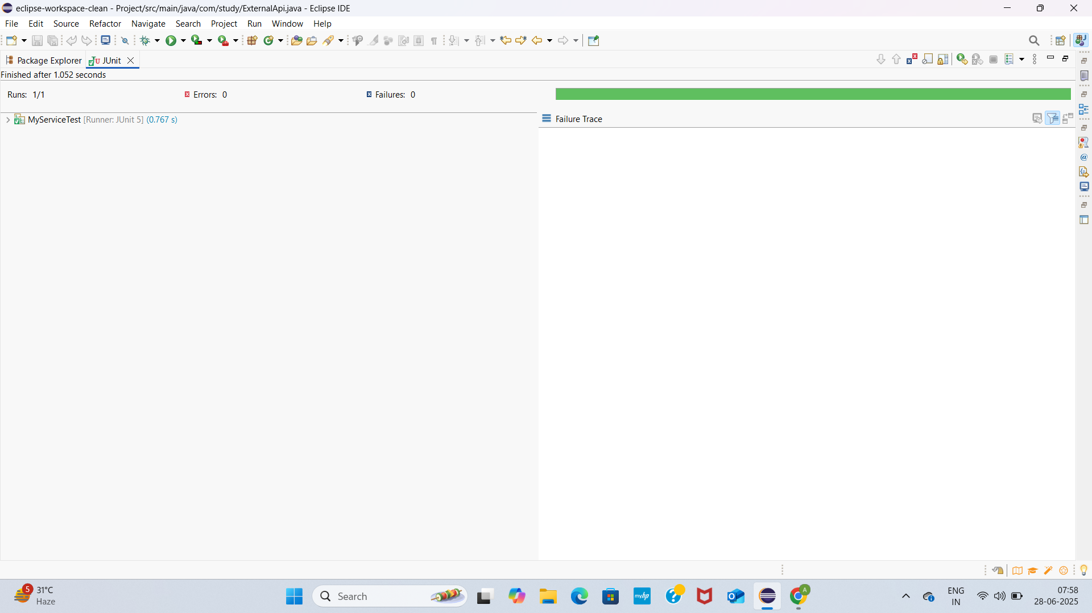4.HANDLING VOID METHODS

MyServiceTest.java

**package** com.study;

**import** **static** org.mockito.Mockito.*;

**import** **static** org.mockito.ArgumentMatchers.*;

**import** org.junit.jupiter.api.Test;

**import** org.mockito.Mockito;

**public** **class** MyServiceTest {

@Test

**public** **void** testArgumentMatching() {

// Step 1: Create mock

ExternalApi mockApi = Mockito.*mock*(ExternalApi.**class**);

// Step 2: Inject mock and call method with specific argument

MyService service = **new** MyService(mockApi);

service.performLogging();

// Step 3: Verify it was called with specific argument using matcher

*verify*(mockApi).log("Action performed");

// You could also match any string like:

// verify(mockApi).sendData(anyString());

}

}

MyService.java

**package** com.study;

**public** **class** MyService {

**private** ExternalApi externalApi;

**public** MyService(ExternalApi externalApi) {

**this**.externalApi = externalApi;

}

**public** **void** performLogging() {

externalApi.log("Action performed");

}

}

ExternalApi

**package** com.study;

**public** **interface** ExternalApi {

**void** log(String message);

}

Pom.xml

<project xmlns="http://maven.apache.org/POM/4.0.0"

xmlns:xsi="http://www.w3.org/2001/XMLSchema-instance"

xsi:schemaLocation="http://maven.apache.org/POM/4.0.0

<http://maven.apache.org/xsd/maven-4.0.0.xsd>">

<modelVersion>4.0.0</modelVersion>

<groupId>com.study</groupId>

<artifactId>Project</artifactId>

<version>1.0-SNAPSHOT</version>

<properties>

<maven.compiler.source>1.8</maven.compiler.source>

<maven.compiler.target>1.8</maven.compiler.target>

<project.build.sourceEncoding>UTF-8</project.build.sourceEncoding>

</properties>

<dependencies>

<!-- ✅ JUnit 5 -->

<dependency>

<groupId>org.junit.jupiter</groupId>

<artifactId>junit-jupiter</artifactId>

<version>5.10.0</version>

<scope>test</scope>

</dependency>

<!-- ✅ Mockito -->

<dependency>

<groupId>org.mockito</groupId>

<artifactId>mockito-core</artifactId>

<version>5.12.0</version>

<scope>test</scope>

</dependency>

</dependencies>

<build>

<plugins>

<!-- Plugin to run JUnit 5 tests -->

<plugin>

<groupId>org.apache.maven.plugins</groupId>

<artifactId>maven-surefire-plugin</artifactId>

<version>3.1.2</version>

<configuration>

<useModulePath>false</useModulePath>

</configuration>

</plugin>

</plugins>

</build>

</project>

OUTPUT SCREENSHOT

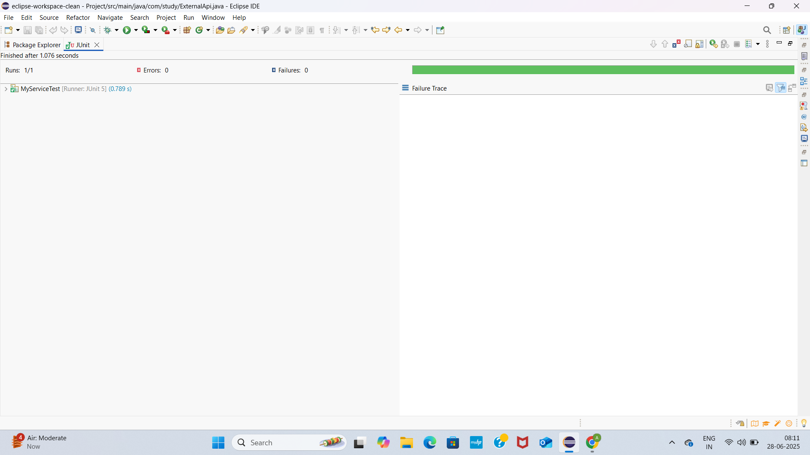

5.MOCKING AND STUBBING WITH MULTIPLE RETURNS

MyServiceTest.java

**package** com.study;

**import** **static** org.mockito.Mockito.*;

**import** **static** org.junit.jupiter.api.Assertions.*;

**import** org.junit.jupiter.api.Test;

**import** org.mockito.Mockito;

**public** **class** MyServiceTest {

@Test

**public** **void** testMultipleReturnValues() {

// Step 1: Create mock object

ExternalApi mockApi = Mockito.*mock*(ExternalApi.**class**);

// Step 2: Stub method to return different values each time

*when*(mockApi.getStatus())

.thenReturn("Pending")

.thenReturn("Processing")

.thenReturn("Complete");

// Step 3: Call method and assert results

MyService service = **new** MyService(mockApi);

String[] statuses = service.checkStatusMultipleTimes();

*assertArrayEquals*(**new** String[] {"Pending", "Processing", "Complete"}, statuses);

}

}

MyService.java

**package** com.study;

**public** **class** MyService {

**private** ExternalApi externalApi;

**public** MyService(ExternalApi externalApi) {

**this**.externalApi = externalApi;

}

**public** String[] checkStatusMultipleTimes() {

**return** **new** String[] {

externalApi.getStatus(), // Call 1

externalApi.getStatus(), // Call 2

externalApi.getStatus() // Call 3

};

}

}

ExternalApi

**package** com.study;

**public** **interface** ExternalApi {

String getStatus();

}

Pom.xml

<project xmlns="http://maven.apache.org/POM/4.0.0"

xmlns:xsi="http://www.w3.org/2001/XMLSchema-instance"

xsi:schemaLocation="http://maven.apache.org/POM/4.0.0

<http://maven.apache.org/xsd/maven-4.0.0.xsd>">

<modelVersion>4.0.0</modelVersion>

<groupId>com.study</groupId>

<artifactId>Project</artifactId>

<version>1.0-SNAPSHOT</version>

<properties>

<maven.compiler.source>1.8</maven.compiler.source>

<maven.compiler.target>1.8</maven.compiler.target>

<project.build.sourceEncoding>UTF-8</project.build.sourceEncoding>

</properties>

<dependencies>

<!-- ✅ JUnit 5 -->

<dependency>

<groupId>org.junit.jupiter</groupId>

<artifactId>junit-jupiter</artifactId>

<version>5.10.0</version>

<scope>test</scope>

</dependency>

<!-- ✅ Mockito -->

<dependency>

<groupId>org.mockito</groupId>

<artifactId>mockito-core</artifactId>

<version>5.12.0</version>

<scope>test</scope>

</dependency>

</dependencies>

<build>

<plugins>

<!-- Plugin to run JUnit 5 tests -->

<plugin>

<groupId>org.apache.maven.plugins</groupId>

<artifactId>maven-surefire-plugin</artifactId>

<version>3.1.2</version>

<configuration>

<useModulePath>false</useModulePath>

</configuration>

</plugin>

</plugins>

</build>

</project>

OUTPUTSCREENSHOT

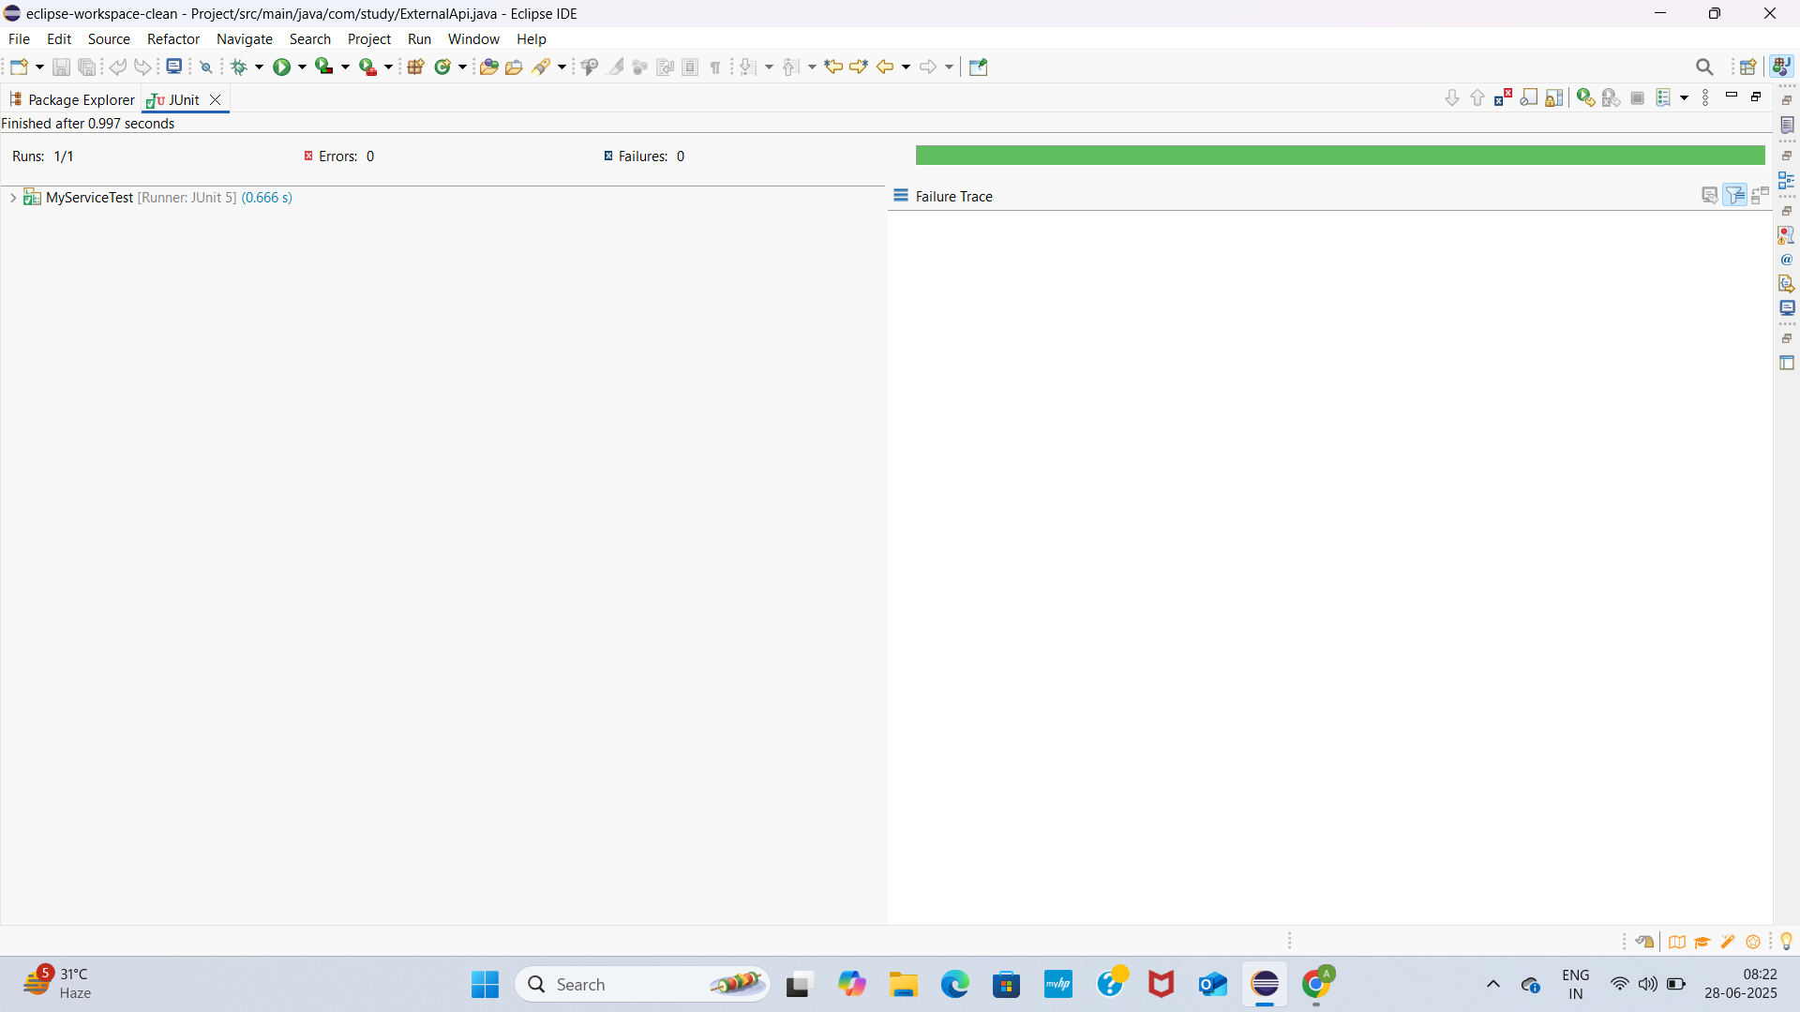

6.VERIFYING INTERACTION ORDER

MyServiceTest.java

package com.study;

import static org.mockito.Mockito.*;

import org.junit.jupiter.api.Test;

import org.mockito.InOrder;

public class MyServiceTest {

@Test

public void testInteractionOrder() {

// Step 1: Create mock

ExternalApi mockApi = mock(ExternalApi.class);

// Step 2: Use the mock in service

MyService service = new MyService(mockApi);

service.execute(); // Calls: connect → send → disconnect

// Step 3: Verify call order

InOrder inOrder = inOrder(mockApi);

inOrder.verify(mockApi).connect();

inOrder.verify(mockApi).send("Hello");

inOrder.verify(mockApi).disconnect();

}

}

MyService.java

**package** com.study;

**public** **class** MyService {

**private** ExternalApi externalApi;

**public** MyService(ExternalApi externalApi) {

**this**.externalApi = externalApi;

}

**public** **void** execute() {

externalApi.connect();

externalApi.send("Hello");

externalApi.disconnect();

}

}

ExternalApi

**package** com.study;

**public** **interface** ExternalApi {

**void** connect();

**void** send(String data);

**void** disconnect();

}

|  |  |
| --- | --- |
|  |  |

Pom.xml

<project xmlns="http://maven.apache.org/POM/4.0.0"

xmlns:xsi="http://www.w3.org/2001/XMLSchema-instance"

xsi:schemaLocation="http://maven.apache.org/POM/4.0.0

<http://maven.apache.org/xsd/maven-4.0.0.xsd>">

<modelVersion>4.0.0</modelVersion>

<groupId>com.study</groupId>

<artifactId>Project</artifactId>

<version>1.0-SNAPSHOT</version>

<properties>

<maven.compiler.source>1.8</maven.compiler.source>

<maven.compiler.target>1.8</maven.compiler.target>

<project.build.sourceEncoding>UTF-8</project.build.sourceEncoding>

</properties>

<dependencies>

<!-- ✅ JUnit 5 -->

<dependency>

<groupId>org.junit.jupiter</groupId>

<artifactId>junit-jupiter</artifactId>

<version>5.10.0</version>

<scope>test</scope>

</dependency>

<!-- ✅ Mockito -->

<dependency>

<groupId>org.mockito</groupId>

<artifactId>mockito-core</artifactId>

<version>5.12.0</version>

<scope>test</scope>

</dependency>

</dependencies>

<build>

<plugins>

<!-- Plugin to run JUnit 5 tests -->

<plugin>

<groupId>org.apache.maven.plugins</groupId>

<artifactId>maven-surefire-plugin</artifactId>

<version>3.1.2</version>

<configuration>

<useModulePath>false</useModulePath>

</configuration>

</plugin>

</plugins>

</build>

</project>

OUTPUT SCREENSHOT

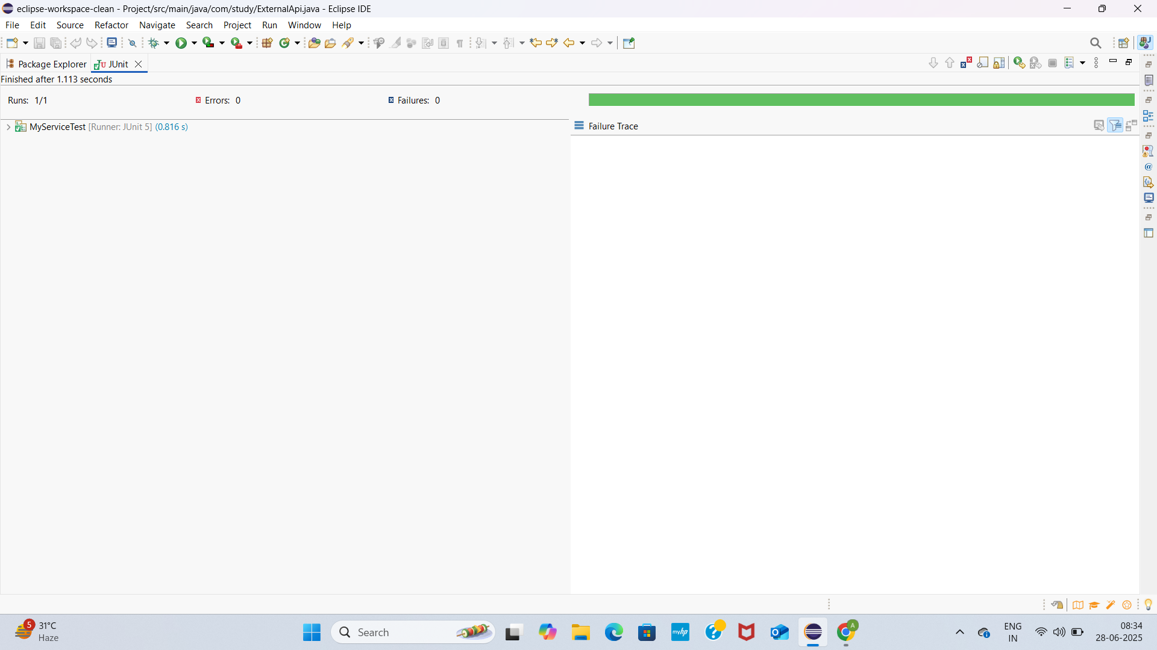

7.HANDLING VOID METHODS

ExternalApi

**package** com.study;

**public** **interface** ExternalApi {

**void** deleteRecord(String id); // void method that may throw

}

MyService.java

**package** com.study;

**public** **class** MyService {

**private** ExternalApi externalApi;

**public** MyService(ExternalApi externalApi) {

**this**.externalApi = externalApi;

}

**public** **void** remove(String id) {

externalApi.deleteRecord(id);

}

}

MyServiceTest.java

**package** com.study;

**import** **static** org.mockito.Mockito.*;

**import** **static** org.junit.jupiter.api.Assertions.*;

**import** org.junit.jupiter.api.Test;

**import** org.mockito.Mockito;

**public** **class** MyServiceTest {

@Test

**public** **void** testVoidMethodThrowsException() {

// Step 1: Create mock

ExternalApi mockApi = Mockito.*mock*(ExternalApi.**class**);

// Step 2: Stub the void method to throw exception

*doThrow*(**new** RuntimeException("Delete failed"))

.when(mockApi).deleteRecord("123");

// Step 3: Create service and call the method (should throw)

MyService service = **new** MyService(mockApi);

// Verify the exception is thrown

RuntimeException ex = *assertThrows*(RuntimeException.**class**, () -> {

service.remove("123");

});

*assertEquals*("Delete failed", ex.getMessage());

// Step 4: Verify the interaction occurred

*verify*(mockApi).deleteRecord("123");

}

}

Pom.xml

<project xmlns="http://maven.apache.org/POM/4.0.0"

xmlns:xsi="http://www.w3.org/2001/XMLSchema-instance"

xsi:schemaLocation="http://maven.apache.org/POM/4.0.0

<http://maven.apache.org/xsd/maven-4.0.0.xsd>">

<modelVersion>4.0.0</modelVersion>

<groupId>com.study</groupId>

<artifactId>Project</artifactId>

<version>1.0-SNAPSHOT</version>

<properties>

<maven.compiler.source>1.8</maven.compiler.source>

<maven.compiler.target>1.8</maven.compiler.target>

<project.build.sourceEncoding>UTF-8</project.build.sourceEncoding>

</properties>

<dependencies>

<!-- ✅ JUnit 5 -->

<dependency>

<groupId>org.junit.jupiter</groupId>

<artifactId>junit-jupiter</artifactId>

<version>5.10.0</version>

<scope>test</scope>

</dependency>

<!-- ✅ Mockito -->

<dependency>

<groupId>org.mockito</groupId>

<artifactId>mockito-core</artifactId>

<version>5.12.0</version>

<scope>test</scope>

</dependency>

</dependencies>

<build>

<plugins>

<!-- Plugin to run JUnit 5 tests -->

<plugin>

<groupId>org.apache.maven.plugins</groupId>

<artifactId>maven-surefire-plugin</artifactId>

<version>3.1.2</version>

<configuration>

<useModulePath>false</useModulePath>

</configuration>

</plugin>

</plugins>

</build>

</project>

OUTPUTSCREENSHOT

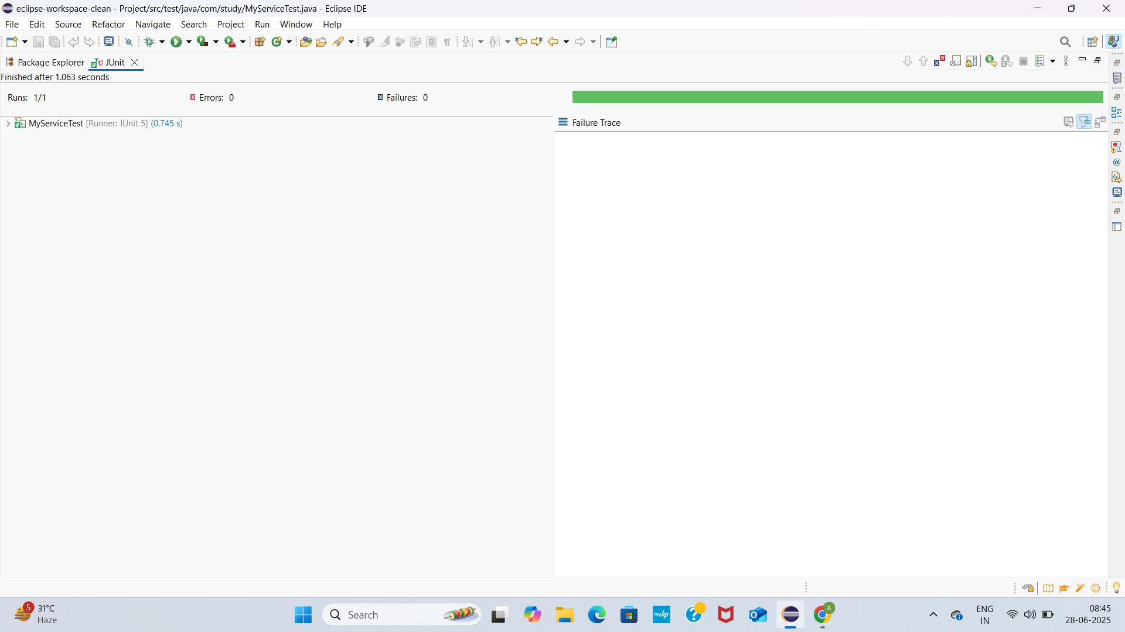

**ADVANCED MOCKITO HANDS ON**

**1.**

**Repository.java**

**package** com.study;

**public** **interface** Repository {

String getData();

}

Service.java

**package** com.study;

**public** **class** Service {

**private** Repository repository;

**public** Service(Repository repository) {

**this**.repository = repository;

}

**public** String processData() {

String data = repository.getData(); // gets "Mock Data"

**return** "Processed " + data; // appends logic

}

}

Servicetest.java

**package** com.study;

**import** **static** org.mockito.Mockito.*;

**import** **static** org.junit.jupiter.api.Assertions.*;

**import** org.junit.jupiter.api.Test;

**public** **class** ServiceTest {

@Test

**public** **void** testServiceWithMockRepository() {

// Step 1: Create a mock repository

Repository mockRepository = *mock*(Repository.**class**);

// Step 2: Stub method to return mock data

*when*(mockRepository.getData()).thenReturn("Mock Data");

// Step 3: Inject into service and test logic

Service service = **new** Service(mockRepository);

String result = service.processData();

// Step 4: Verify result

*assertEquals*("Processed Mock Data", result);

}

}

Pom.xml

<project xmlns="http://maven.apache.org/POM/4.0.0"

xmlns:xsi="http://www.w3.org/2001/XMLSchema-instance"

xsi:schemaLocation="http://maven.apache.org/POM/4.0.0

<http://maven.apache.org/xsd/maven-4.0.0.xsd>">

<modelVersion>4.0.0</modelVersion>

<groupId>com.study</groupId>

<artifactId>Project</artifactId>

<version>1.0-SNAPSHOT</version>

<properties>

<maven.compiler.source>1.8</maven.compiler.source>

<maven.compiler.target>1.8</maven.compiler.target>

<project.build.sourceEncoding>UTF-8</project.build.sourceEncoding>

</properties>

<dependencies>

<!-- ✅ JUnit 5 -->

<dependency>

<groupId>org.junit.jupiter</groupId>

<artifactId>junit-jupiter</artifactId>

<version>5.10.0</version>

<scope>test</scope>

</dependency>

<!-- ✅ Mockito -->

<dependency>

<groupId>org.mockito</groupId>

<artifactId>mockito-core</artifactId>

<version>5.12.0</version>

<scope>test</scope>

</dependency>

</dependencies>

<build>

<plugins>

<!-- Plugin to run JUnit 5 tests -->

<plugin>

<groupId>org.apache.maven.plugins</groupId>

<artifactId>maven-surefire-plugin</artifactId>

<version>3.1.2</version>

<configuration>

<useModulePath>false</useModulePath>

</configuration>

</plugin>

</plugins>

</build>

</project>

OUTPUT SCREENSHOT

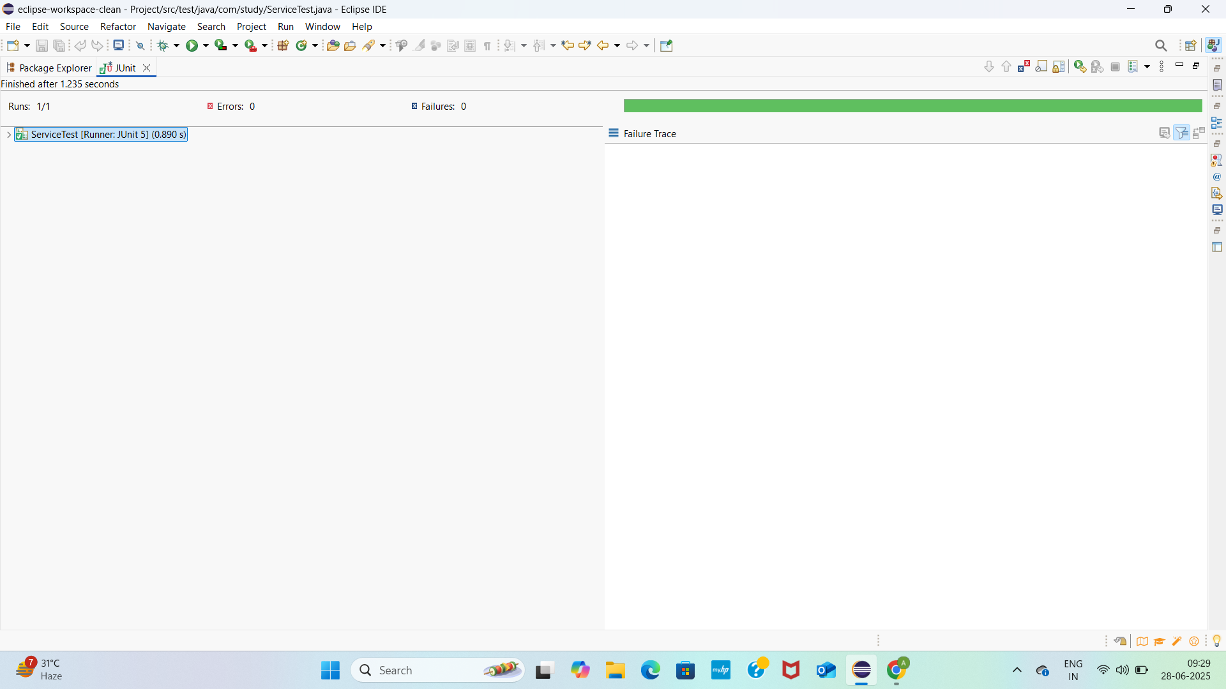

2. **package** com.study;

**public** **interface** RestClient {

String getResponse();

}

ApiService.java

**package** com.study;

**public** **class** ApiService {

**private** RestClient restClient;

**public** ApiService(RestClient restClient) {

**this**.restClient = restClient;

}

**public** String fetchData() {

String response = restClient.getResponse(); // calls mocked REST API

**return** "Fetched " + response; // processes result

}

}

ApiServiceTest.java

**package** com.study;

**import** **static** org.mockito.Mockito.*;

**import** **static** org.junit.jupiter.api.Assertions.*;

**import** org.junit.jupiter.api.Test;

**public** **class** ApiServiceTest {

@Test

**public** **void** testServiceWithMockRestClient() {

// Step 1: Create mock REST client

RestClient mockRestClient = *mock*(RestClient.**class**);

// Step 2: Stub the response

*when*(mockRestClient.getResponse()).thenReturn("Mock Response");

// Step 3: Inject into service and test

ApiService apiService = **new** ApiService(mockRestClient);

String result = apiService.fetchData();

// Step 4: Verify logic

*assertEquals*("Fetched Mock Response", result);

}

}

Pom.xml

<project xmlns="http://maven.apache.org/POM/4.0.0"

xmlns:xsi="http://www.w3.org/2001/XMLSchema-instance"

xsi:schemaLocation="http://maven.apache.org/POM/4.0.0

<http://maven.apache.org/xsd/maven-4.0.0.xsd>">

<modelVersion>4.0.0</modelVersion>

<groupId>com.study</groupId>

<artifactId>Project</artifactId>

<version>1.0-SNAPSHOT</version>

<properties>

<maven.compiler.source>1.8</maven.compiler.source>

<maven.compiler.target>1.8</maven.compiler.target>

<project.build.sourceEncoding>UTF-8</project.build.sourceEncoding>

</properties>

<dependencies>

<!-- ✅ JUnit 5 -->

<dependency>

<groupId>org.junit.jupiter</groupId>

<artifactId>junit-jupiter</artifactId>

<version>5.10.0</version>

<scope>test</scope>

</dependency>

<!-- ✅ Mockito -->

<dependency>

<groupId>org.mockito</groupId>

<artifactId>mockito-core</artifactId>

<version>5.12.0</version>

<scope>test</scope>

</dependency>

</dependencies>

<build>

<plugins>

<!-- Plugin to run JUnit 5 tests -->

<plugin>

<groupId>org.apache.maven.plugins</groupId>

<artifactId>maven-surefire-plugin</artifactId>

<version>3.1.2</version>

<configuration>

<useModulePath>false</useModulePath>

</configuration>

</plugin>

</plugins>

</build>

</project>

OUTPUTSCREENSHOT

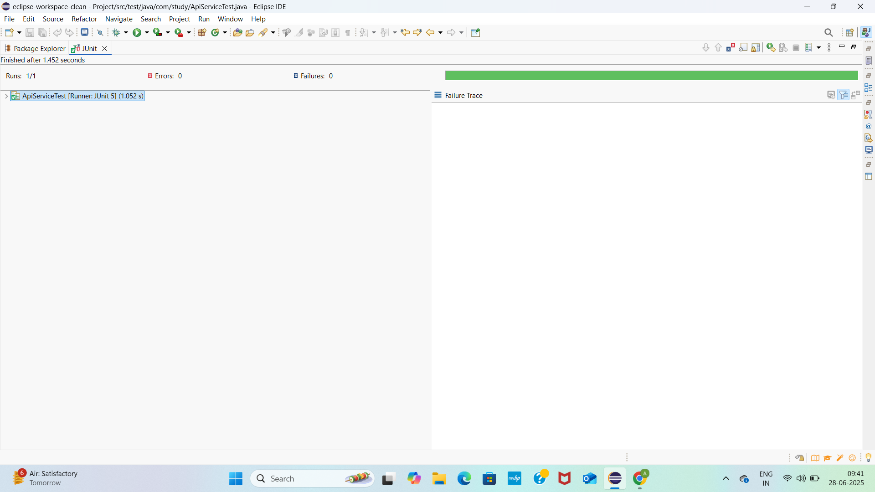

3. FileReader.java

**package** com.study;

**public** **interface** FileReader {

String read();

}

FileWriter.java

**package** com.study;

**public** **interface** FileWriter {

**void** write(String data);

}

FileService.java

**package** com.study;

**public** **class** FileService {

**private** FileReader fileReader;

**private** FileWriter fileWriter;

**public** FileService(FileReader fileReader, FileWriter fileWriter) {

**this**.fileReader = fileReader;

**this**.fileWriter = fileWriter;

}

**public** String processFile() {

String content = fileReader.read(); // Simulate reading file

String processed = "Processed " + content;

fileWriter.write(processed); // Simulate writing file

**return** processed;

}

}

FileServiceTest.java

**package** com.study;

**import** **static** org.mockito.Mockito.*;

**import** **static** org.junit.jupiter.api.Assertions.*;

**import** org.junit.jupiter.api.Test;

**public** **class** FileServiceTest {

@Test

**public** **void** testServiceWithMockFileIO() {

// Step 1: Create mock FileReader and FileWriter

FileReader mockFileReader = *mock*(FileReader.**class**);

FileWriter mockFileWriter = *mock*(FileWriter.**class**);

// Step 2: Stub the FileReader to return mock content

*when*(mockFileReader.read()).thenReturn("Mock File Content");

// Step 3: Create the service with mocks

FileService fileService = **new** FileService(mockFileReader, mockFileWriter);

// Step 4: Call the service method

String result = fileService.processFile();

// Step 5: Verify result and that FileWriter was called correctly

*assertEquals*("Processed Mock File Content", result);

*verify*(mockFileWriter).write("Processed Mock File Content"); // Interaction verification

}

}

Pom.xml

<project xmlns="http://maven.apache.org/POM/4.0.0"

xmlns:xsi="http://www.w3.org/2001/XMLSchema-instance"

xsi:schemaLocation="http://maven.apache.org/POM/4.0.0

<http://maven.apache.org/xsd/maven-4.0.0.xsd>">

<modelVersion>4.0.0</modelVersion>

<groupId>com.study</groupId>

<artifactId>Project</artifactId>

<version>1.0-SNAPSHOT</version>

<properties>

<maven.compiler.source>1.8</maven.compiler.source>

<maven.compiler.target>1.8</maven.compiler.target>

<project.build.sourceEncoding>UTF-8</project.build.sourceEncoding>

</properties>

<dependencies>

<!-- ✅ JUnit 5 -->

<dependency>

<groupId>org.junit.jupiter</groupId>

<artifactId>junit-jupiter</artifactId>

<version>5.10.0</version>

<scope>test</scope>

</dependency>

<!-- ✅ Mockito -->

<dependency>

<groupId>org.mockito</groupId>

<artifactId>mockito-core</artifactId>

<version>5.12.0</version>

<scope>test</scope>

</dependency>

</dependencies>

<build>

<plugins>

<!-- Plugin to run JUnit 5 tests -->

<plugin>

<groupId>org.apache.maven.plugins</groupId>

<artifactId>maven-surefire-plugin</artifactId>

<version>3.1.2</version>

<configuration>

<useModulePath>false</useModulePath>

</configuration>

</plugin>

</plugins>

</build>

</project>

OUTPUT SCREENSHOT

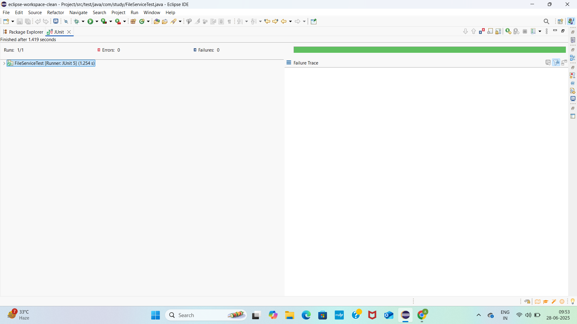

4.

NetworkClient.java

**package** com.study;

**public** **interface** NetworkClient {

String connect();

}

NetworkService.java

**package** com.study;

**public** **class** NetworkService {

**private** NetworkClient networkClient;

**public** NetworkService(NetworkClient networkClient) {

**this**.networkClient = networkClient;

}

**public** String connectToServer() {

String connection = networkClient.connect(); // simulate a real connection

**return** "Connected to " + connection; // service logic

}

}

NetworkServiceTest.java

**package** com.study;

**import** **static** org.mockito.Mockito.*;

**import** **static** org.junit.jupiter.api.Assertions.*;

**import** org.junit.jupiter.api.Test;

**public** **class** NetworkServiceTest {

@Test

**public** **void** testServiceWithMockNetworkClient() {

// Step 1: Create mock network client

NetworkClient mockNetworkClient = *mock*(NetworkClient.**class**);

// Step 2: Stub the connect method

*when*(mockNetworkClient.connect()).thenReturn("Mock Connection");

// Step 3: Inject into service and test

NetworkService networkService = **new** NetworkService(mockNetworkClient);

String result = networkService.connectToServer();

// Step 4: Verify output

*assertEquals*("Connected to Mock Connection", result);

// Optional: Verify interaction

*verify*(mockNetworkClient).connect();

}

}

Pom.xml

<project xmlns="http://maven.apache.org/POM/4.0.0"

xmlns:xsi="http://www.w3.org/2001/XMLSchema-instance"

xsi:schemaLocation="http://maven.apache.org/POM/4.0.0

<http://maven.apache.org/xsd/maven-4.0.0.xsd>">

<modelVersion>4.0.0</modelVersion>

<groupId>com.study</groupId>

<artifactId>Project</artifactId>

<version>1.0-SNAPSHOT</version>

<properties>

<maven.compiler.source>1.8</maven.compiler.source>

<maven.compiler.target>1.8</maven.compiler.target>

<project.build.sourceEncoding>UTF-8</project.build.sourceEncoding>

</properties>

<dependencies>

<!-- ✅ JUnit 5 -->

<dependency>

<groupId>org.junit.jupiter</groupId>

<artifactId>junit-jupiter</artifactId>

<version>5.10.0</version>

<scope>test</scope>

</dependency>

<!-- ✅ Mockito -->

<dependency>

<groupId>org.mockito</groupId>

<artifactId>mockito-core</artifactId>

<version>5.12.0</version>

<scope>test</scope>

</dependency>

</dependencies>

<build>

<plugins>

<!-- Plugin to run JUnit 5 tests -->

<plugin>

<groupId>org.apache.maven.plugins</groupId>

<artifactId>maven-surefire-plugin</artifactId>

<version>3.1.2</version>

<configuration>

<useModulePath>false</useModulePath>

</configuration>

</plugin>

</plugins>

</build>

</project>

OUTPUTSCREENSHOT

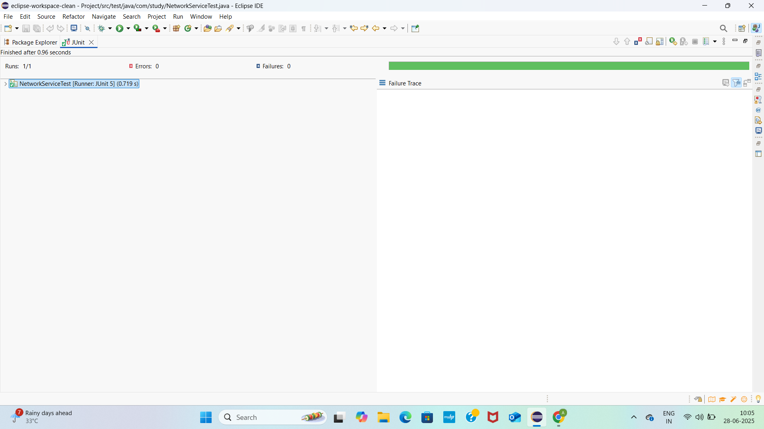

5.

Repository.java

**package** com.study;

**public** **interface** Repository {

String getData();

}

Service.java

**package** com.study;

**public** **class** Service {

**private** Repository repository;

**public** Service(Repository repository) {

**this**.repository = repository;

}

**public** String processData() {

String data = repository.getData(); // gets "Mock Data"

**return** "Processed " + data; // appends logic

}

}

MultiReturnServiceTest.java

**package** com.study;

**import** **static** org.mockito.Mockito.*;

**import** **static** org.junit.jupiter.api.Assertions.*;

**import** org.junit.jupiter.api.Test;

**public** **class** MultiReturnServiceTest {

@Test

**public** **void** testServiceWithMultipleReturnValues() {

// Step 1: Create mock

Repository mockRepository = *mock*(Repository.**class**);

// Step 2: Stub with multiple return values

*when*(mockRepository.getData())

.thenReturn("First Mock Data")

.thenReturn("Second Mock Data");

// Step 3: Inject into service and call twice

Service service = **new** Service(mockRepository);

String firstResult = service.processData();

String secondResult = service.processData();

// Step 4: Verify both results

*assertEquals*("Processed First Mock Data", firstResult);

*assertEquals*("Processed Second Mock Data", secondResult);

// Optional: Verify interaction count

*verify*(mockRepository, *times*(2)).getData();

}

}

Pom.xml

<project xmlns="http://maven.apache.org/POM/4.0.0"

xmlns:xsi="http://www.w3.org/2001/XMLSchema-instance"

xsi:schemaLocation="http://maven.apache.org/POM/4.0.0

<http://maven.apache.org/xsd/maven-4.0.0.xsd>">

<modelVersion>4.0.0</modelVersion>

<groupId>com.study</groupId>

<artifactId>Project</artifactId>

<version>1.0-SNAPSHOT</version>

<properties>

<maven.compiler.source>1.8</maven.compiler.source>

<maven.compiler.target>1.8</maven.compiler.target>

<project.build.sourceEncoding>UTF-8</project.build.sourceEncoding>

</properties>

<dependencies>

<!-- ✅ JUnit 5 -->

<dependency>

<groupId>org.junit.jupiter</groupId>

<artifactId>junit-jupiter</artifactId>

<version>5.10.0</version>

<scope>test</scope>

</dependency>

<!-- ✅ Mockito -->

<dependency>

<groupId>org.mockito</groupId>

<artifactId>mockito-core</artifactId>

<version>5.12.0</version>

<scope>test</scope>

</dependency>

</dependencies>

<build>

<plugins>

<!-- Plugin to run JUnit 5 tests -->

<plugin>

<groupId>org.apache.maven.plugins</groupId>

<artifactId>maven-surefire-plugin</artifactId>

<version>3.1.2</version>

<configuration>

<useModulePath>false</useModulePath>

</configuration>

</plugin>

</plugins>

</build>

</project>

OUTPUT SCREENSHOT

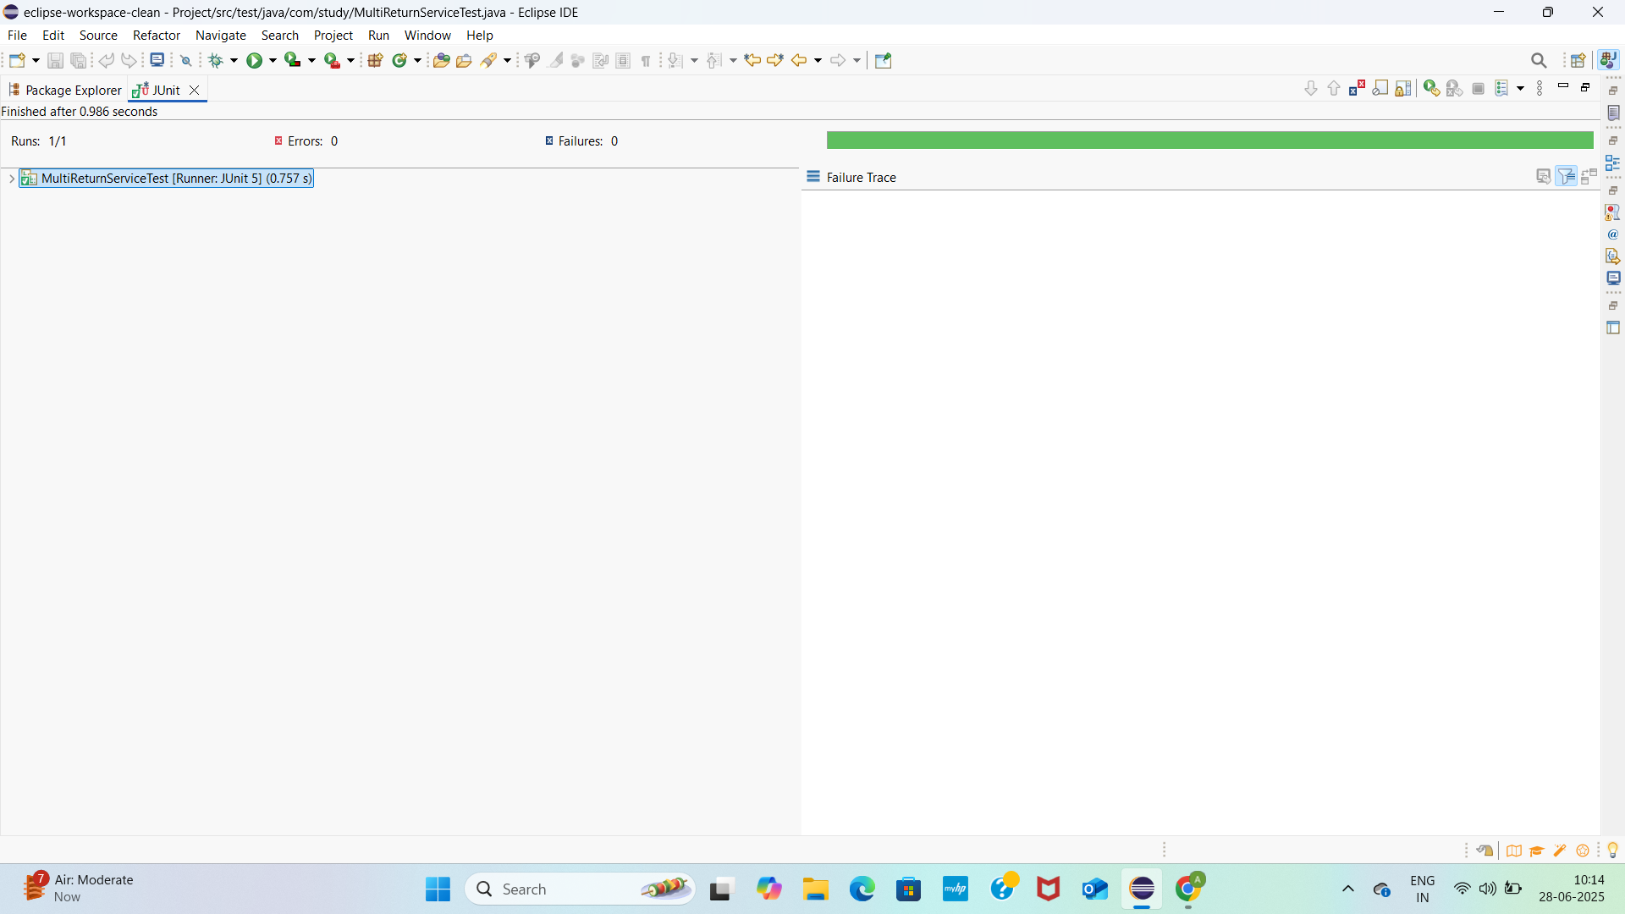

**SPRING TESTING EXERCISE**

**1.**

CalculatorService.java

**package** com.study;

**import** org.springframework.stereotype.Service;

@Service

**public** **class** CalculatorService {

**public** **int** add(**int** a, **int** b) {

**return** a + b;

}

}

CalculatorServiceTest.java

**package** com.study;

**import** **static** org.junit.jupiter.api.Assertions.*;

**import** org.junit.jupiter.api.Test;

**public** **class** CalculatorServiceTest {

@Test

**public** **void** testAdd() {

CalculatorService calculatorService = **new** CalculatorService();

**int** result = calculatorService.add(5, 3);

*assertEquals*(8, result, "5 + 3 should equal 8");

}

}

Pom.xml

<project xmlns="http://maven.apache.org/POM/4.0.0"

xmlns:xsi="http://www.w3.org/2001/XMLSchema-instance"

xsi:schemaLocation="http://maven.apache.org/POM/4.0.0

<http://maven.apache.org/xsd/maven-4.0.0.xsd>">

<modelVersion>4.0.0</modelVersion>

<groupId>com.study</groupId>

<artifactId>spring-junit-example</artifactId>

<version>1.0-SNAPSHOT</version>

<properties>

<java.version>17</java.version>

<spring.version>6.1.6</spring.version>

<junit.version>5.10.0</junit.version>

<mockito.version>5.12.0</mockito.version>

<maven.compiler.source>${java.version}</maven.compiler.source>

<maven.compiler.target>${java.version}</maven.compiler.target>

</properties>

<dependencies>

<!-- Spring Core (for @Service, etc.) -->

<dependency>

<groupId>org.springframework</groupId>

<artifactId>spring-context</artifactId>

<version>${spring.version}</version>

</dependency>

<!-- JUnit 5 -->

<dependency>

<groupId>org.junit.jupiter</groupId>

<artifactId>junit-jupiter</artifactId>

<version>${junit.version}</version>

<scope>test</scope>

</dependency>

<!-- Mockito -->

<dependency>

<groupId>org.mockito</groupId>

<artifactId>mockito-core</artifactId>

<version>${mockito.version}</version>

<scope>test</scope>

</dependency>

</dependencies>

<build>

<plugins>

<!-- Use Maven Surefire Plugin for JUnit 5 -->

<plugin>

<groupId>org.apache.maven.plugins</groupId>

<artifactId>maven-surefire-plugin</artifactId>

<version>3.2.5</version>

<configuration>

<useModulePath>false</useModulePath>

</configuration>

</plugin>

</plugins>

</build>

</project>

OUTPUTSCREENSHOT

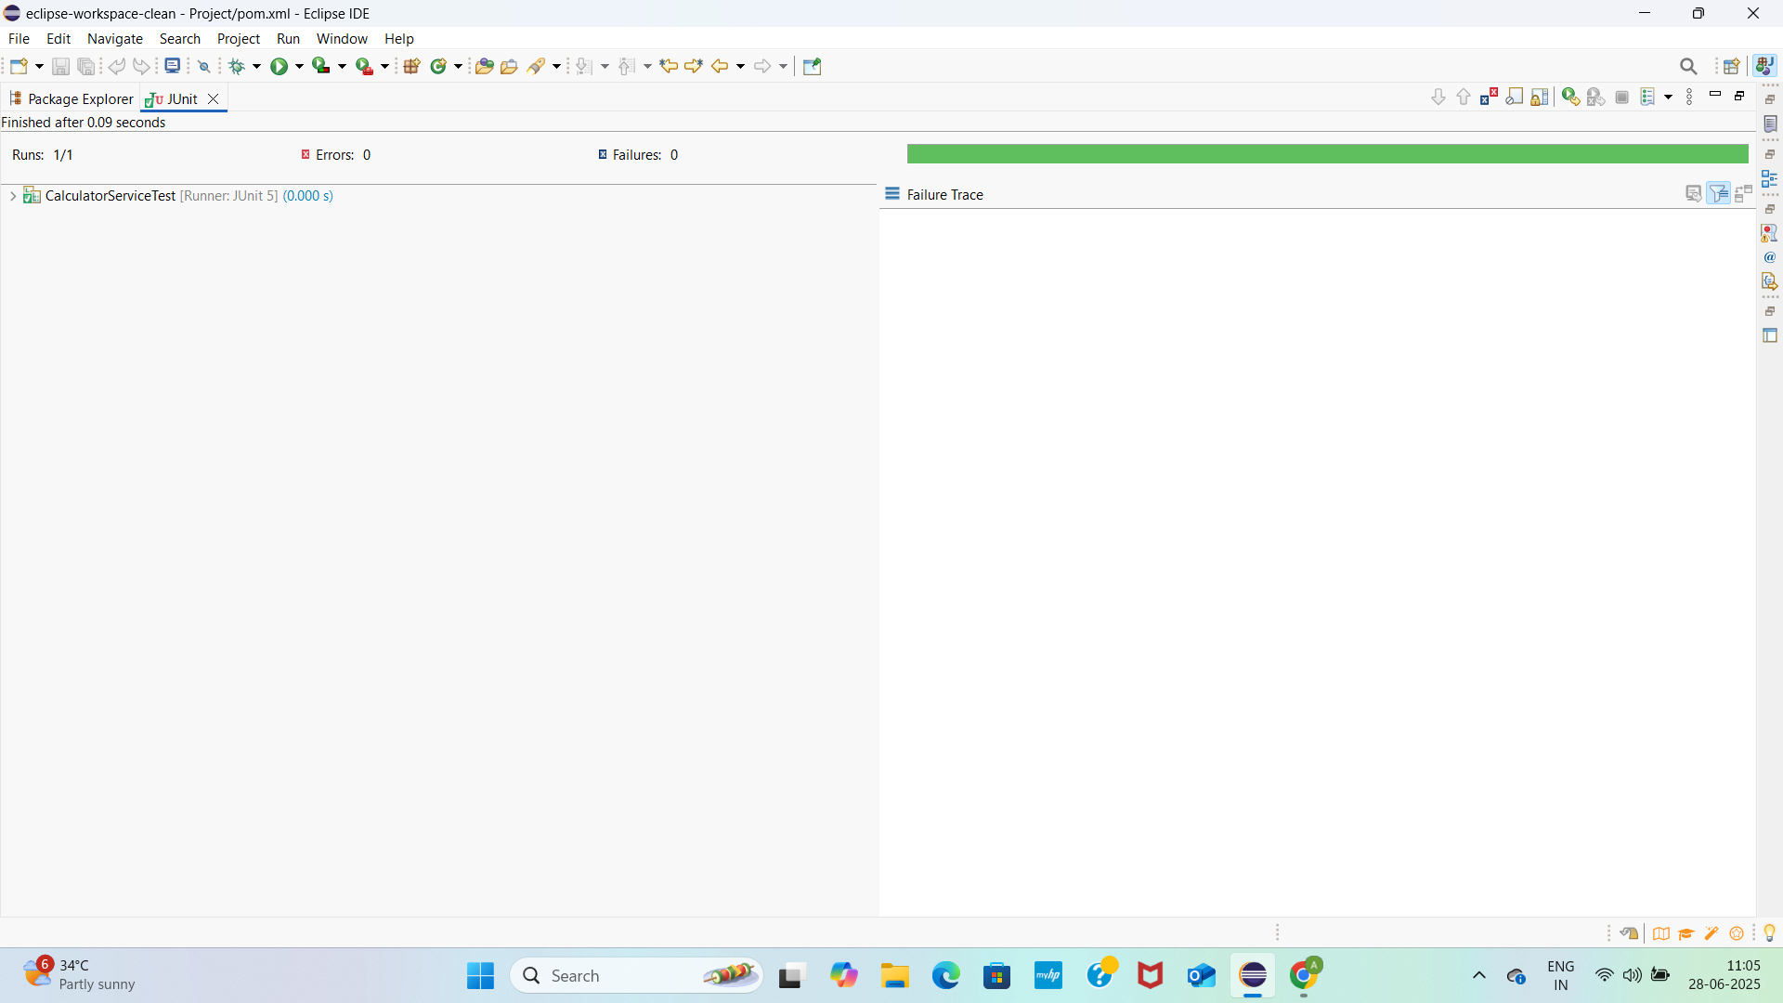

MOCKING DEPENDENCIES IN SPRING TESTS USING MOCKITO

1.

UserControllerTest.java

**package** com.study;

**import** org.junit.jupiter.api.Test;

**import** org.springframework.boot.test.autoconfigure.web.servlet.WebMvcTest;

**import** org.springframework.boot.test.mock.mockito.MockBean;

**import** org.springframework.beans.factory.annotation.Autowired;

**import** org.springframework.test.web.servlet.MockMvc;

**import** **static** org.mockito.Mockito.*when*;

**import** **static** org.springframework.test.web.servlet.request.MockMvcRequestBuilders.*get*;

**import** **static** org.springframework.test.web.servlet.result.MockMvcResultMatchers.*;

@WebMvcTest(UserController.**class**)

**public** **class** UserControllerTest {

@Autowired

**private** MockMvc mockMvc;

@MockBean

**private** UserService userService;

@Test

**public** **void** testGetUserById() **throws** Exception {

*when*(userService.getUserById(1L)).thenReturn("Mocked User");

mockMvc.perform(*get*("/users/1"))

.andExpect(*status*().isOk())

.andExpect(*content*().string("Mocked User"));

}

}

UserController.java

**package** com.study;

**import** org.springframework.beans.factory.annotation.Autowired;

**import** org.springframework.http.ResponseEntity;

**import** org.springframework.web.bind.annotation.PathVariable;

**import** org.springframework.web.bind.annotation.GetMapping;

**import** org.springframework.web.bind.annotation.RequestMapping;

**import** org.springframework.web.bind.annotation.RestController;

@RestController

@RequestMapping("/users")

**public** **class** UserController {

@Autowired

**private** UserService userService;

@GetMapping("/{id}")

**public** ResponseEntity<String> getUser(@PathVariable Long id) {

**return** ResponseEntity.*ok*(userService.getUserById(id));

}

}

UserService.java

**package** com.study;

**public** **interface** UserService {

String getUserById(Long id);

}

Pom.xml

<project xmlns="http://maven.apache.org/POM/4.0.0"

xmlns:xsi="http://www.w3.org/2001/XMLSchema-instance"

xsi:schemaLocation="http://maven.apache.org/POM/4.0.0

<http://maven.apache.org/xsd/maven-4.0.0.xsd>">

<modelVersion>4.0.0</modelVersion>

<parent>

<groupId>org.springframework.boot</groupId>

<artifactId>spring-boot-starter-parent</artifactId>

<version>3.2.5</version>

<relativePath/>

</parent>

<groupId>com.study</groupId>

<artifactId>spring-basic</artifactId>

<version>1.0.0</version>

<properties>

<java.version>17</java.version>

</properties>

<dependencies>

<!-- ✅ Spring Web -->

<dependency>

<groupId>org.springframework.boot</groupId>

<artifactId>spring-boot-starter-web</artifactId>

</dependency>

<!-- ✅ JUnit 5 + Mockito -->

<dependency>

<groupId>org.springframework.boot</groupId>

<artifactId>spring-boot-starter-test</artifactId>

<scope>test</scope>

</dependency>

</dependencies>

<build>

<plugins>

<!-- ✅ Spring Boot Plugin -->

<plugin>

<groupId>org.springframework.boot</groupId>

<artifactId>spring-boot-maven-plugin</artifactId>

</plugin>

</plugins>

</build>

</project>

OUTPUTSCREENSHOT

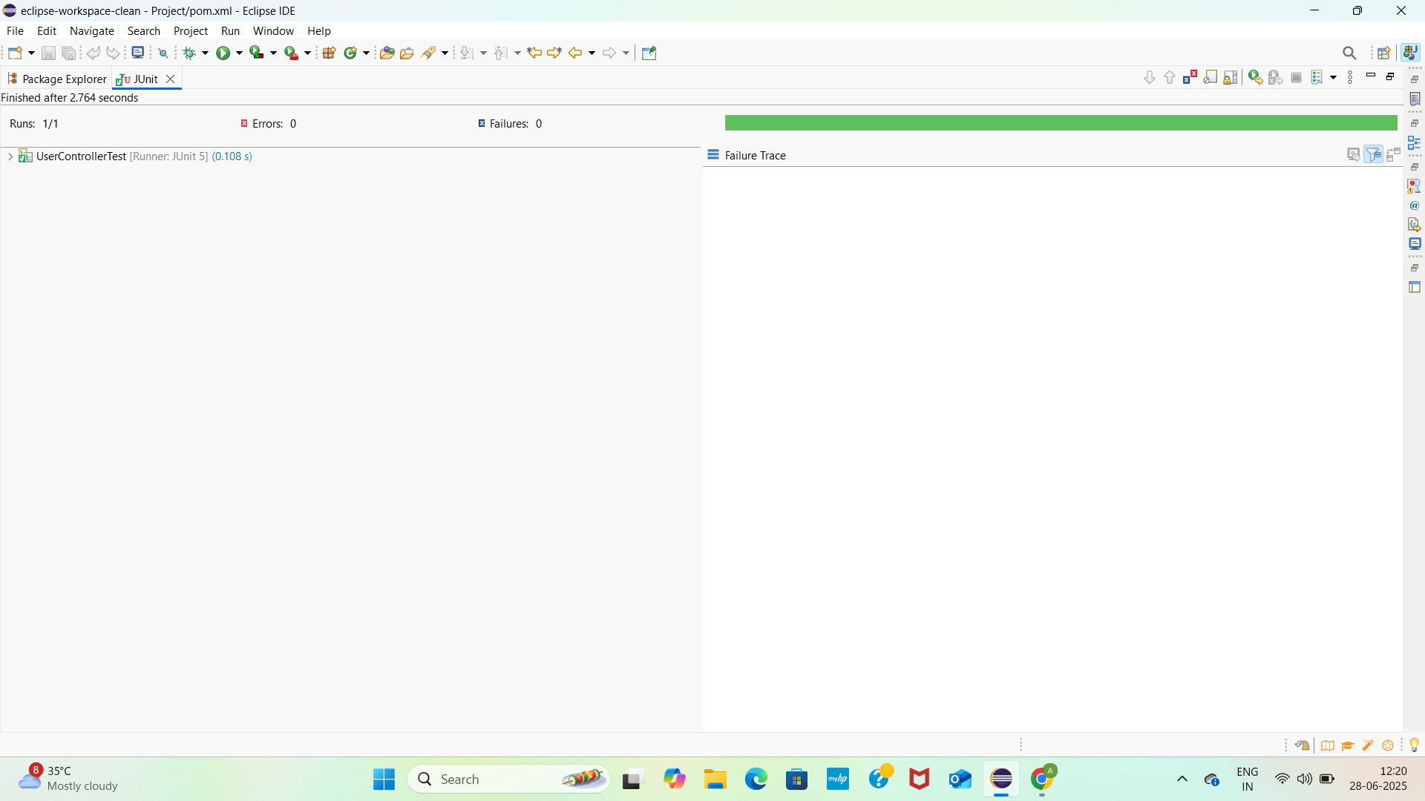

2.

User.java

**package** com.study;

**public** **class** User {

**private** Long id;

**private** String name;

**public** User(Long id, String name) {

**this**.id = id;

**this**.name = name;

}

**public** Long getId() {

**return** id;

}

**public** String getName() {

**return** name;

}

}

UserRepository.java

**package** com.study;

**import** java.util.HashMap;

**import** java.util.Map;

**import** java.util.Optional;

**public** **class** UserRepository {

**private** **static** **final** Map<Long, User> ***store*** = **new** HashMap<>();

**static** {

***store***.put(1L, **new** User(1L, "Alice"));

***store***.put(2L, **new** User(2L, "Bob"));

}

**public** Optional<User> findById(Long id) {

**return** Optional.*ofNullable*(***store***.get(id));

}

}

UserService.java

**package** com.study;

**public** **class** UserService {

**private** **final** UserRepository userRepository;

**public** UserService(UserRepository userRepository) {

**this**.userRepository = userRepository;

}

**public** User getUserById(Long id) {

**return** userRepository.findById(id).orElse(**null**);

}

}

UserServiceTest.java

**package** com.study;

**import** org.junit.jupiter.api.Test;

**import** **static** org.junit.jupiter.api.Assertions.*;

**public** **class** UserServiceTest {

@Test

**public** **void** testGetUserById_Found() {

UserRepository repo = **new** UserRepository();

UserService service = **new** UserService(repo);

User user = service.getUserById(1L);

*assertNotNull*(user);

*assertEquals*("Alice", user.getName());

}

@Test

**public** **void** testGetUserById_NotFound() {

UserRepository repo = **new** UserRepository();

UserService service = **new** UserService(repo);

User user = service.getUserById(99L);

*assertNull*(user);

}

}

Pom.xml

<project xmlns="http://maven.apache.org/POM/4.0.0"

xmlns:xsi="http://www.w3.org/2001/XMLSchema-instance"

xsi:schemaLocation="http://maven.apache.org/POM/4.0.0

<http://maven.apache.org/xsd/maven-4.0.0.xsd>">

<modelVersion>4.0.0</modelVersion>

<parent>

<groupId>org.springframework.boot</groupId>

<artifactId>spring-boot-starter-parent</artifactId>

<version>3.2.5</version>

<relativePath/>

</parent>

<groupId>com.study</groupId>

<artifactId>spring-basic</artifactId>

<version>1.0.0</version>

<properties>

<java.version>17</java.version>

</properties>

<dependencies>

<!-- ✅ Spring Web -->

<dependency>

<groupId>org.springframework.boot</groupId>

<artifactId>spring-boot-starter-web</artifactId>

</dependency>

<!-- ✅ JUnit 5 + Mockito -->

<dependency>

<groupId>org.springframework.boot</groupId>

<artifactId>spring-boot-starter-test</artifactId>

<scope>test</scope>

</dependency>

</dependencies>

<build>

<plugins>

<!-- ✅ Spring Boot Plugin -->

<plugin>

<groupId>org.springframework.boot</groupId>

<artifactId>spring-boot-maven-plugin</artifactId>

</plugin>

</plugins>

</build>

</project>

OUTPUT SCREENSHOT

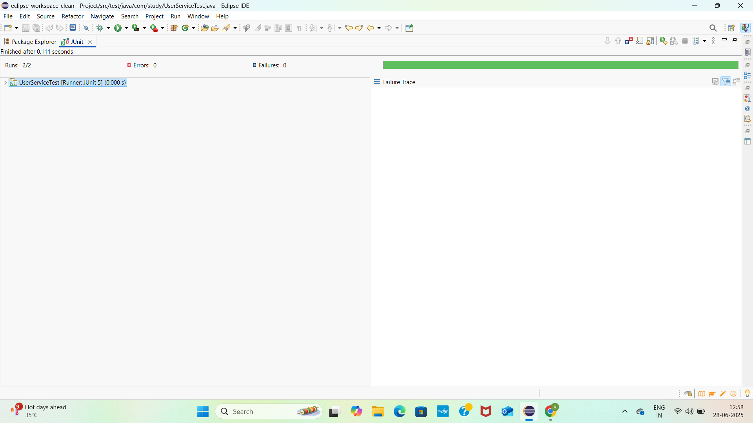

3. UserController.java

**package** com.study;

**import** org.springframework.beans.factory.annotation.Autowired;

**import** org.springframework.http.ResponseEntity;

**import** org.springframework.web.bind.annotation.*;

@RestController

@RequestMapping("/users")

**public** **class** UserController {

@Autowired

**private** UserService userService;

@GetMapping("/{id}")

**public** ResponseEntity<User> getUser(@PathVariable Long id) {

User user = userService.getUserById(id);

**if** (user != **null**) {

**return** ResponseEntity.*ok*(user);

} **else** {

**return** ResponseEntity.*notFound*().build();

}

}

}

User.java

**package** com.study;

**public** **class** User {

**private** Long id;

**private** String name;

**public** User(Long id, String name) {

**this**.id = id;

**this**.name = name;

}

**public** Long getId() {

**return** id;

}

**public** String getName() {

**return** name;

}

}

UserRepository.java

**package** com.study;

**import** java.util.HashMap;

**import** java.util.Map;

**import** java.util.Optional;

**public** **class** UserRepository {

**private** **static** **final** Map<Long, User> ***store*** = **new** HashMap<>();

**static** {

***store***.put(1L, **new** User(1L, "Alice"));

***store***.put(2L, **new** User(2L, "Bob"));

}

**public** Optional<User> findById(Long id) {

**return** Optional.*ofNullable*(***store***.get(id));

}

}

UserService.java

**package** com.study;

**import** org.springframework.stereotype.Service;

@Service

**public** **class** UserService {

**private** **final** UserRepository userRepository = **new** UserRepository(); // Manual injection for simplicity

**public** User getUserById(Long id) {

**return** userRepository.findById(id).orElse(**null**);

}

}

SpringApp.java

**package** com.study;

**import** org.springframework.boot.SpringApplication;

**import** org.springframework.boot.autoconfigure.SpringBootApplication;

@SpringBootApplication

**public** **class** SpringApp {

**public** **static** **void** main(String[] args) {

SpringApplication.*run*(SpringApp.**class**, args);

}

}

UserControllerTest.java

**package** com.study;

**import** org.junit.jupiter.api.Test;

**import** org.springframework.beans.factory.annotation.Autowired;

**import** org.springframework.boot.test.autoconfigure.web.servlet.WebMvcTest;

**import** org.springframework.boot.test.mock.mockito.MockBean;

**import** org.springframework.test.web.servlet.MockMvc;

**import** **static** org.mockito.Mockito.*when*;

**import** **static** org.springframework.test.web.servlet.request.MockMvcRequestBuilders.*get*;

**import** **static** org.springframework.test.web.servlet.result.MockMvcResultMatchers.*;

@WebMvcTest(UserController.**class**)

**public** **class** UserControllerTest {

@Autowired

**private** MockMvc mockMvc;

@MockBean

**private** UserService userService;

@Test

**public** **void** testGetUser_Found() **throws** Exception {

*when*(userService.getUserById(1L)).thenReturn(**new** User(1L, "Alice"));

mockMvc.perform(*get*("/users/1"))

.andExpect(*status*().isOk())

.andExpect(*jsonPath*("$.name").value("Alice"));

}

@Test

**public** **void** testGetUser_NotFound() **throws** Exception {

*when*(userService.getUserById(99L)).thenReturn(**null**);

mockMvc.perform(*get*("/users/99"))

.andExpect(*status*().isNotFound());

}

}

Pom.xml

<project xmlns="http://maven.apache.org/POM/4.0.0"

xmlns:xsi="http://www.w3.org/2001/XMLSchema-instance"

xsi:schemaLocation="http://maven.apache.org/POM/4.0.0

<http://maven.apache.org/xsd/maven-4.0.0.xsd>">

<modelVersion>4.0.0</modelVersion>

<parent>

<groupId>org.springframework.boot</groupId>

<artifactId>spring-boot-starter-parent</artifactId>

<version>3.2.5</version>

<relativePath/>

</parent>

<groupId>com.study</groupId>

<artifactId>spring-basic</artifactId>

<version>1.0.0</version>

<properties>

<java.version>17</java.version>

</properties>

<dependencies>

<!-- ✅ Spring Web -->

<dependency>

<groupId>org.springframework.boot</groupId>

<artifactId>spring-boot-starter-web</artifactId>

</dependency>

<!-- ✅ JUnit 5 + Mockito -->

<dependency>

<groupId>org.springframework.boot</groupId>

<artifactId>spring-boot-starter-test</artifactId>

<scope>test</scope>

</dependency>

</dependencies>

<build>

<plugins>

<!-- ✅ Spring Boot Plugin -->

<plugin>

<groupId>org.springframework.boot</groupId>

<artifactId>spring-boot-maven-plugin</artifactId>

</plugin>

</plugins>

</build>

</project>

OUTPUTSCREENSHOT

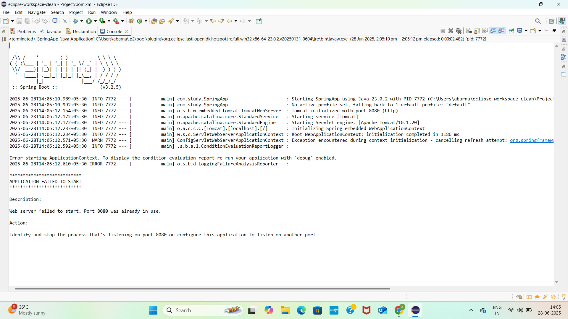

4.

UserService.java

**package** com.study;

**import** org.springframework.stereotype.Service;

@Service

**public** **class** UserService {

**private** **final** UserRepository userRepository;

// ✅ Constructor for Spring to inject UserRepository

**public** UserService(UserRepository userRepository) {

**this**.userRepository = userRepository;

}

**public** User getUserById(Long id) {

**return** userRepository.findById(id).orElse(**null**);

}

}

UserRepository.java

**package** com.study;

**import** org.springframework.stereotype.Repository;

**import** java.util.HashMap;

**import** java.util.Map;

**import** java.util.Optional;

@Repository

**public** **class** UserRepository {

**private** **static** **final** Map<Long, User> ***users*** = **new** HashMap<>();

**static** {

***users***.put(1L, **new** User(1L, "Alice"));

***users***.put(2L, **new** User(2L, "Bob"));

}

**public** Optional<User> findById(Long id) {

**return** Optional.*ofNullable*(***users***.get(id));

}

}

UserController.java

**package** com.study;

**import** org.springframework.beans.factory.annotation.Autowired;

**import** org.springframework.http.ResponseEntity;

**import** org.springframework.web.bind.annotation.*;

@RestController

@RequestMapping("/users")

**public** **class** UserController {

**private** **final** UserService userService;

// ✅ Constructor-based injection

**public** UserController(UserService userService) {

**this**.userService = userService;

}

@GetMapping("/{id}")

**public** ResponseEntity<User> getUser(@PathVariable Long id) {

User user = userService.getUserById(id);

**if** (user != **null**) {

**return** ResponseEntity.*ok*(user);

} **else** {

**return** ResponseEntity.*notFound*().build();

}

}

}

SpringApp.java

**package** com.study;

**import** org.springframework.boot.SpringApplication;

**import** org.springframework.boot.autoconfigure.SpringBootApplication;

@SpringBootApplication

**public** **class** SpringApp {

**public** **static** **void** main(String[] args) {

SpringApplication.*run*(SpringApp.**class**, args);

}

}

OUTPUTSCREENSHOT

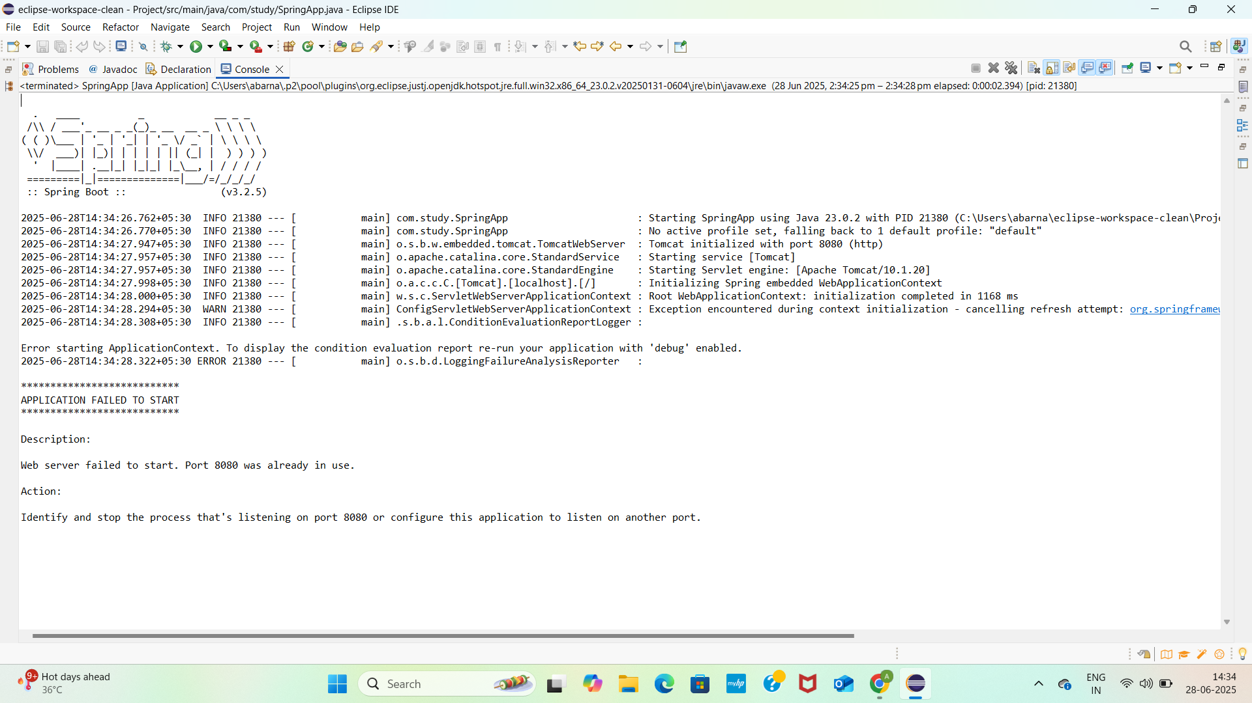



2.User.java

**package** com.study;

**public** **class** User {

**private** Long id;

**private** String name;

**public** User() {

}

**public** User(Long id, String name) {

**this**.id = id;

**this**.name = name;

}

**public** Long getId() {

**return** id;

}

**public** **void** setId(Long id) {

**this**.id = id;

}

**public** String getName() {

**return** name;

}

**public** **void** setName(String name) {

**this**.name = name;

}

}

UserRepository.java

**package** com.study;

**import** java.util.Optional;

**public** **interface** UserRepository {

Optional<User> findById(Long id);

}

UserService.java

**package** com.study;

**import** org.springframework.beans.factory.annotation.Autowired;

**import** org.springframework.stereotype.Service;

@Service

**public** **class** UserService {

@Autowired

**private** UserRepository userRepository;

**public** User getUserById(Long id) {

**return** userRepository.findById(id).orElse(**null**);

}

}

UserServiceTest.java

**package** com.study;

**import** **static** org.junit.jupiter.api.Assertions.*;

**import** **static** org.mockito.Mockito.*;

**import** java.util.Optional;

**import** org.junit.jupiter.api.BeforeEach;

**import** org.junit.jupiter.api.Test;

**import** org.mockito.InjectMocks;

**import** org.mockito.Mock;

**import** org.mockito.MockitoAnnotations;

**public** **class** UserServiceTest {

@Mock

**private** UserRepository userRepository;

@InjectMocks

**private** UserService userService;

@BeforeEach

**public** **void** setUp() {

MockitoAnnotations.*openMocks*(**this**);

}

@Test

**public** **void** testGetUserById_UserFound() {

// Use constructor, no setters needed

User mockUser = **new** User(1L, "Alice");

*when*(userRepository.findById(1L)).thenReturn(Optional.*of*(mockUser));

User result = userService.getUserById(1L);

*assertNotNull*(result);

*assertEquals*("Alice", result.getName());

*assertEquals*(1L, result.getId());

}

@Test

**public** **void** testGetUserById_UserNotFound() {

*when*(userRepository.findById(99L)).thenReturn(Optional.*empty*());

User result = userService.getUserById(99L);

*assertNull*(result);

}

}

OUTPUTSCREENSHOT

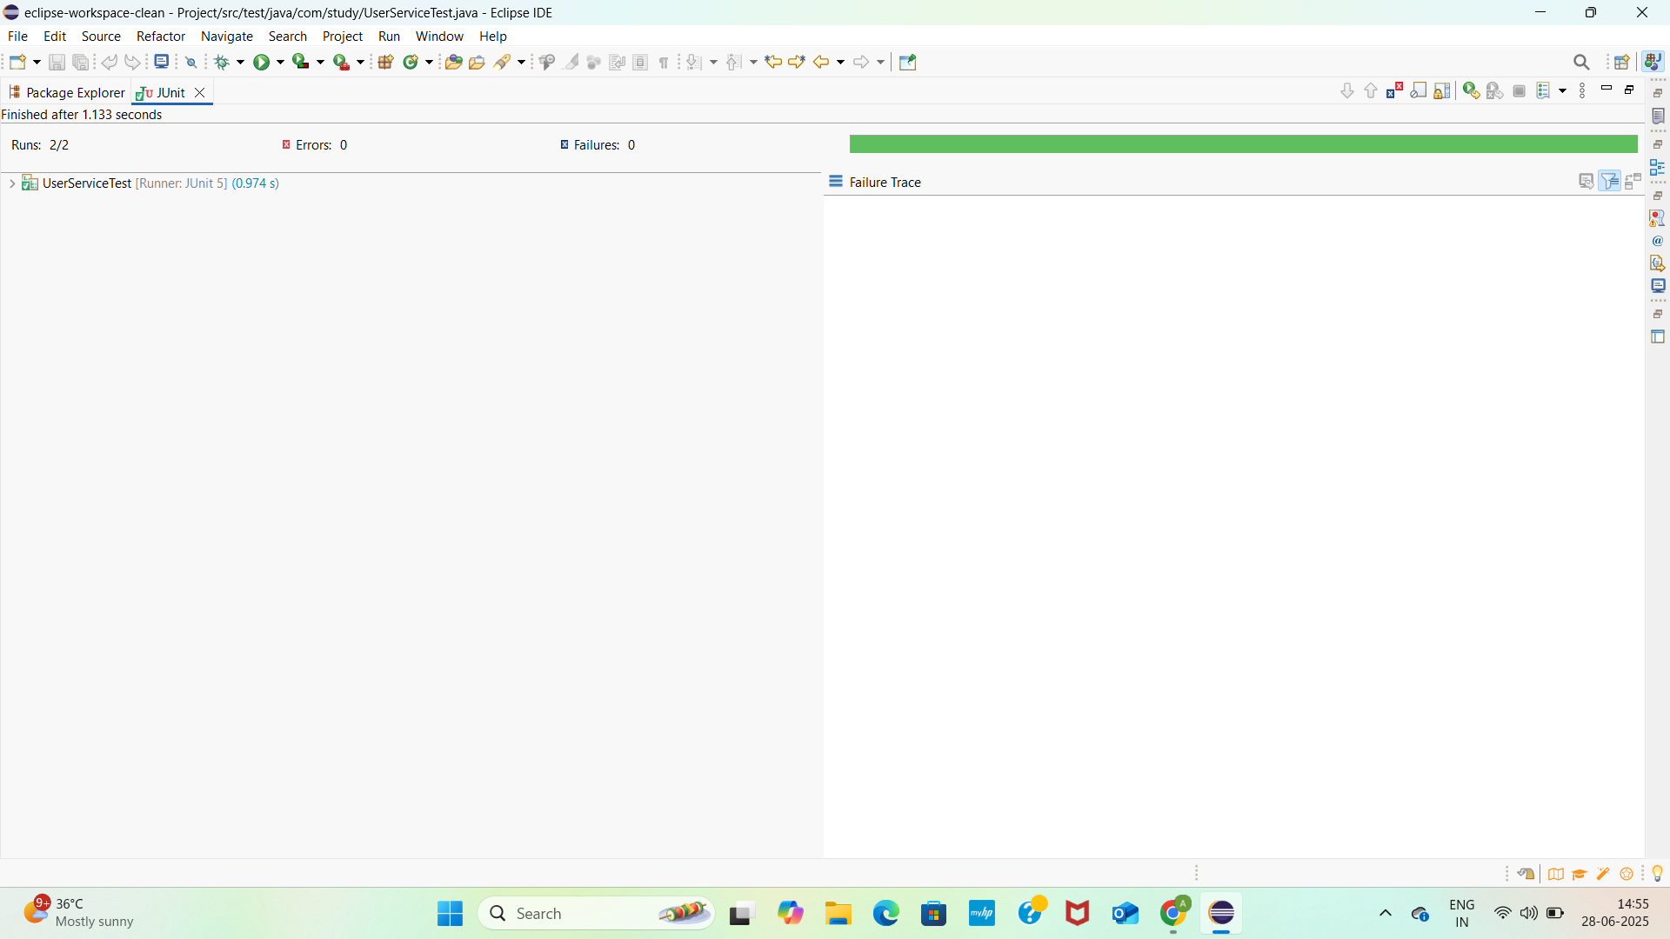

3.

User.java

**package** com.study;

**public** **class** User {

**private** Long id;

**private** String name;

**public** User() {}

**public** User(Long id, String name) {

**this**.id = id;

**this**.name = name;

}

**public** Long getId() { **return** id; }

**public** **void** setId(Long id) { **this**.id = id; }

**public** String getName() { **return** name; }

**public** **void** setName(String name) { **this**.name = name;}

}

UserService.java

**package** com.study;

**public** **interface** UserService {

User getUserById(Long id);

}

UserController.java

**package** com.study;

**public** **class** UserController {

**private** **final** UserService userService;

**public** UserController(UserService userService) {

**this**.userService = userService;

}

**public** User getUserById(Long id) {

**return** userService.getUserById(id);

}

}

UserControllerTest.java

**package** com.study;

**import** org.junit.jupiter.api.Test;

**import** **static** org.mockito.Mockito.*;

**import** **static** org.junit.jupiter.api.Assertions.*;

**public** **class** UserControllerTest {

@Test

**public** **void** testGetUserById() {

// Arrange

UserService mockService = *mock*(UserService.**class**);

UserController controller = **new** UserController(mockService);

User mockUser = **new** User(1L, "John Doe");

*when*(mockService.getUserById(1L)).thenReturn(mockUser);

// Act

User result = controller.getUserById(1L);

// Assert

*assertNotNull*(result);

*assertEquals*(1L, result.getId());

*assertEquals*("John Doe", result.getName());

// Verify interaction

*verify*(mockService).getUserById(1L);

}

}

OUTPUTSCREENSHOT

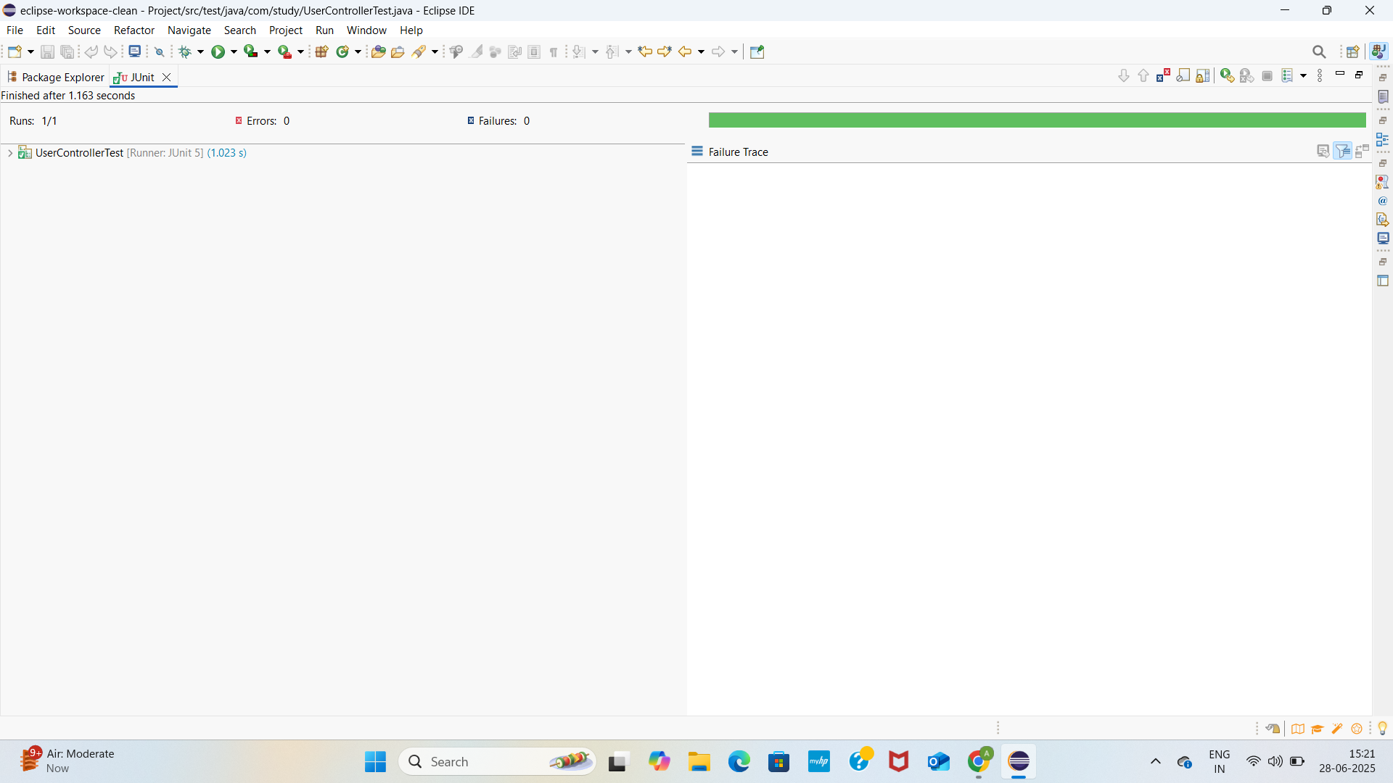

Logging using SLF4J

1. LoggingExample.java

**package** com.study;

**import** org.slf4j.Logger;

**import** org.slf4j.LoggerFactory;

**public** **class** LoggingExample {

**private** **static** **final** Logger ***logger*** = LoggerFactory.*getLogger*(LoggingExample.**class**);

**public** **static** **void** main(String[] args) {

***logger***.error("This is an error message");

***logger***.warn("This is a warning message");

***logger***.info("This is an info message");

}

}

Pom.xml

<project xmlns="http://maven.apache.org/POM/4.0.0"

xmlns:xsi="http://www.w3.org/2001/XMLSchema-instance"

xsi:schemaLocation="http://maven.apache.org/POM/4.0.0

<http://maven.apache.org/xsd/maven-4.0.0.xsd>">

<modelVersion>4.0.0</modelVersion>

<groupId>com.study</groupId>

<artifactId>spring-logging-test</artifactId>

<version>1.0-SNAPSHOT</version>

<properties>

<java.version>1.8</java.version>

<junit.version>5.7.0</junit.version>

<mockito.version>3.6.0</mockito.version>

<spring.version>5.3.3</spring.version>

</properties>

<dependencies>

<!-- ✅ SLF4J Logging -->

<dependency>

<groupId>org.slf4j</groupId>

<artifactId>slf4j-api</artifactId>

<version>1.7.30</version>

</dependency>

<!-- ✅ Logback (SLF4J implementation) -->

<dependency>

<groupId>ch.qos.logback</groupId>

<artifactId>logback-classic</artifactId>

<version>1.2.3</version>

</dependency>

<!-- ✅ Spring Core -->

<dependency>

<groupId>org.springframework</groupId>

<artifactId>spring-context</artifactId>

<version>${spring.version}</version>

</dependency>

<!-- ✅ JUnit 5 (Jupiter) -->

<dependency>

<groupId>org.junit.jupiter</groupId>

<artifactId>junit-jupiter-api</artifactId>

<version>${junit.version}</version>

<scope>test</scope>

</dependency>

<dependency>

<groupId>org.junit.jupiter</groupId>

<artifactId>junit-jupiter-engine</artifactId>

<version>${junit.version}</version>

<scope>test</scope>

</dependency>

<!-- ✅ Mockito Core -->

<dependency>

<groupId>org.mockito</groupId>

<artifactId>mockito-core</artifactId>

<version>${mockito.version}</version>

<scope>test</scope>

</dependency>

<!-- ✅ Mockito + JUnit 5 integration -->

<dependency>

<groupId>org.mockito</groupId>

<artifactId>mockito-junit-jupiter</artifactId>

<version>${mockito.version}</version>

<scope>test</scope>

</dependency>

<!-- ✅ Spring Test Support -->

<dependency>

<groupId>org.springframework</groupId>

<artifactId>spring-test</artifactId>

<version>${spring.version}</version>

<scope>test</scope>

</dependency>

</dependencies>

<build>

<plugins>

<!-- Compiler plugin -->

<plugin>

<groupId>org.apache.maven.plugins</groupId>

<artifactId>maven-compiler-plugin</artifactId>

<version>3.8.1</version>

<configuration>

<source>${java.version}</source>

<target>${java.version}</target>

</configuration>

</plugin>

<!-- Surefire for running JUnit 5 -->

<plugin>

<groupId>org.apache.maven.plugins</groupId>

<artifactId>maven-surefire-plugin</artifactId>

<version>2.22.2</version>

<configuration>

<includes>

<include>**/*Test.java</include>

</includes>

</configuration>

</plugin>

</plugins>

</build>

</project>

OUTPUT SCREENSHOT

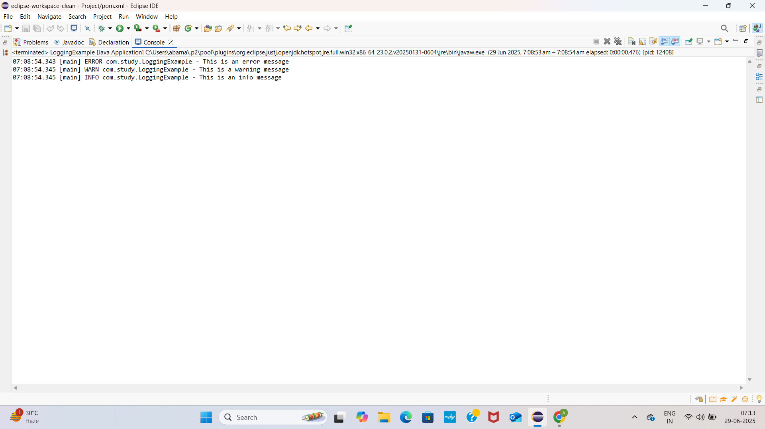

2.

ParameterizedLoggingExample.java

**package** com.study;

**import** org.slf4j.Logger;

**import** org.slf4j.LoggerFactory;

**public** **class** ParameterizedLoggingExample {

**private** **static** **final** Logger ***logger*** = LoggerFactory.*getLogger*(ParameterizedLoggingExample.**class**);

**public** **static** **void** main(String[] args) {

String username = "Abarna";

**int** loginAttempts = 3;

***logger***.info("User {} has attempted to login {} times", username, loginAttempts);

***logger***.warn("User {} may be locked out after {} failed attempts", username, loginAttempts);

***logger***.error("Login failed for user {} after {} attempts", username, loginAttempts);

// Logging with one parameter

***logger***.debug("Current user is {}", username);

// Logging without parameters

***logger***.info("Logging completed.");

}

}

Pom.xml

<project xmlns="http://maven.apache.org/POM/4.0.0"

xmlns:xsi="http://www.w3.org/2001/XMLSchema-instance"

xsi:schemaLocation="http://maven.apache.org/POM/4.0.0

<http://maven.apache.org/xsd/maven-4.0.0.xsd>">

<modelVersion>4.0.0</modelVersion>

<groupId>com.study</groupId>

<artifactId>spring-logging-test</artifactId>

<version>1.0-SNAPSHOT</version>

<properties>

<java.version>1.8</java.version>

<junit.version>5.7.0</junit.version>

<mockito.version>3.6.0</mockito.version>

<spring.version>5.3.3</spring.version>

</properties>

<dependencies>

<!-- ✅ SLF4J Logging -->

<dependency>

<groupId>org.slf4j</groupId>

<artifactId>slf4j-api</artifactId>

<version>1.7.30</version>

</dependency>

<!-- ✅ Logback (SLF4J implementation) -->

<dependency>

<groupId>ch.qos.logback</groupId>

<artifactId>logback-classic</artifactId>

<version>1.2.3</version>

</dependency>

<!-- ✅ Spring Core -->

<dependency>

<groupId>org.springframework</groupId>

<artifactId>spring-context</artifactId>

<version>${spring.version}</version>

</dependency>

<!-- ✅ JUnit 5 (Jupiter) -->

<dependency>

<groupId>org.junit.jupiter</groupId>

<artifactId>junit-jupiter-api</artifactId>

<version>${junit.version}</version>

<scope>test</scope>

</dependency>

<dependency>

<groupId>org.junit.jupiter</groupId>

<artifactId>junit-jupiter-engine</artifactId>

<version>${junit.version}</version>

<scope>test</scope>

</dependency>

<!-- ✅ Mockito Core -->

<dependency>

<groupId>org.mockito</groupId>

<artifactId>mockito-core</artifactId>

<version>${mockito.version}</version>

<scope>test</scope>

</dependency>

<!-- ✅ Mockito + JUnit 5 integration -->

<dependency>

<groupId>org.mockito</groupId>

<artifactId>mockito-junit-jupiter</artifactId>

<version>${mockito.version}</version>

<scope>test</scope>

</dependency>

<!-- ✅ Spring Test Support -->

<dependency>

<groupId>org.springframework</groupId>

<artifactId>spring-test</artifactId>

<version>${spring.version}</version>

<scope>test</scope>

</dependency>

</dependencies>

<build>

<plugins>

<!-- Compiler plugin -->

<plugin>

<groupId>org.apache.maven.plugins</groupId>

<artifactId>maven-compiler-plugin</artifactId>

<version>3.8.1</version>

<configuration>

<source>${java.version}</source>

<target>${java.version}</target>

</configuration>

</plugin>

<!-- Surefire for running JUnit 5 -->

<plugin>

<groupId>org.apache.maven.plugins</groupId>

<artifactId>maven-surefire-plugin</artifactId>

<version>2.22.2</version>

<configuration>

<includes>

<include>**/*Test.java</include>

</includes>

</configuration>

</plugin>

</plugins>

</build>

</project>

OUTPUTSCREENSHOT

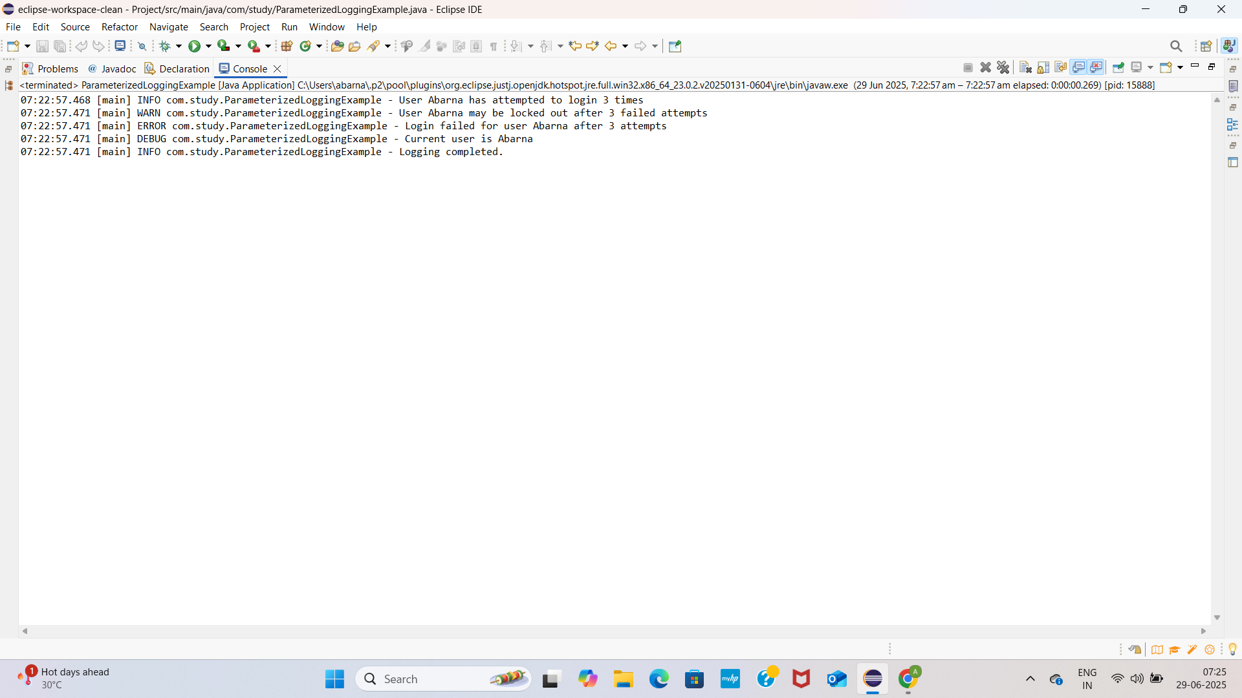

3.

MultiAppenderExample.java

**package** com.study;

**import** org.slf4j.Logger;

**import** org.slf4j.LoggerFactory;

**public** **class** MultiAppenderExample {

**private** **static** **final** Logger ***logger*** = LoggerFactory.*getLogger*(MultiAppenderExample.**class**);

**public** **static** **void** main(String[] args) {

***logger***.info("Starting the multi-appender logging example...");

***logger***.debug("This is a debug message.");

***logger***.warn("This is a warning message.");

***logger***.error("This is an error message.");

***logger***.info("Finished logging.");

}

}

Logback.xml

<configuration>

<!-- Console Appender -->

<appender name="console" class="ch.qos.logback.core.ConsoleAppender">

<encoder>

<pattern>%d{HH:mm:ss.SSS} [%thread] %-5level %logger{36} - %msg%n</pattern>

</encoder>

</appender>

<!-- File Appender -->

<appender name="file" class="ch.qos.logback.core.FileAppender">

<file>app.log</file> <!-- File will be created in project root -->

<append>true</append>

<encoder>

<pattern>%d{HH:mm:ss.SSS} [%thread] %-5level %logger{36} - %msg%n</pattern>

</encoder>

</appender>

<!-- Root Logger Config -->

<root level="debug">

<appender-ref ref="console" />

<appender-ref ref="file" />

</root>

</configuration>

Pom.xml

<project xmlns="http://maven.apache.org/POM/4.0.0"

xmlns:xsi="http://www.w3.org/2001/XMLSchema-instance"

xsi:schemaLocation="http://maven.apache.org/POM/4.0.0

<http://maven.apache.org/xsd/maven-4.0.0.xsd>">

<modelVersion>4.0.0</modelVersion>

<groupId>com.study</groupId>

<artifactId>spring-logging-test</artifactId>

<version>1.0-SNAPSHOT</version>

<properties>

<java.version>1.8</java.version>

<junit.version>5.7.0</junit.version>

<mockito.version>3.6.0</mockito.version>

<spring.version>5.3.3</spring.version>

</properties>

<dependencies>

<!-- ✅ SLF4J Logging -->

<dependency>

<groupId>org.slf4j</groupId>

<artifactId>slf4j-api</artifactId>

<version>1.7.30</version>

</dependency>

<!-- ✅ Logback (SLF4J implementation) -->

<dependency>

<groupId>ch.qos.logback</groupId>

<artifactId>logback-classic</artifactId>

<version>1.2.3</version>

</dependency>

<!-- ✅ Spring Core -->

<dependency>

<groupId>org.springframework</groupId>

<artifactId>spring-context</artifactId>

<version>${spring.version}</version>

</dependency>

<!-- ✅ JUnit 5 (Jupiter) -->

<dependency>

<groupId>org.junit.jupiter</groupId>

<artifactId>junit-jupiter-api</artifactId>

<version>${junit.version}</version>

<scope>test</scope>

</dependency>

<dependency>

<groupId>org.junit.jupiter</groupId>

<artifactId>junit-jupiter-engine</artifactId>

<version>${junit.version}</version>

<scope>test</scope>

</dependency>

<!-- ✅ Mockito Core -->

<dependency>

<groupId>org.mockito</groupId>

<artifactId>mockito-core</artifactId>

<version>${mockito.version}</version>

<scope>test</scope>

</dependency>

<!-- ✅ Mockito + JUnit 5 integration -->

<dependency>

<groupId>org.mockito</groupId>

<artifactId>mockito-junit-jupiter</artifactId>

<version>${mockito.version}</version>

<scope>test</scope>

</dependency>

<!-- ✅ Spring Test Support -->

<dependency>

<groupId>org.springframework</groupId>

<artifactId>spring-test</artifactId>

<version>${spring.version}</version>

<scope>test</scope>

</dependency>

</dependencies>

<build>

<plugins>

<!-- Compiler plugin -->

<plugin>

<groupId>org.apache.maven.plugins</groupId>

<artifactId>maven-compiler-plugin</artifactId>

<version>3.8.1</version>

<configuration>

<source>${java.version}</source>

<target>${java.version}</target>

</configuration>

</plugin>

<!-- Surefire for running JUnit 5 -->

<plugin>

<groupId>org.apache.maven.plugins</groupId>

<artifactId>maven-surefire-plugin</artifactId>

<version>2.22.2</version>

<configuration>

<includes>

<include>**/*Test.java</include>

</includes>

</configuration>

</plugin>

</plugins>

</build>

</project>

OUTPUTSCREENSHOT

